**Development of three cornerstones for a sustainable Energy future in Iran**

Paper 2

**Energy Price Reform in Iran**

**Iran Energy Association**

**Wuppertal Institute for Climate, Environment, and Energy**

Draft 1: April 2010

Draft 2: August 2010

Contents

|  |  |  |  |
| --- | --- | --- | --- |
| 1 | Introduction | | 3 |
| 2 | Objectives of Subsidy | | 4 |
| 3 | Energy Prices and Actual Costs | | 6 |
| 4 | Energy Subsidies | | 8 |
| 5 | Consequences of subventions in Iran | | 14 |
|  | 5.1 | Energy Subsidies Problems | 14 |
|  | 5.2 | Macroeconomic Effects of Energy Price Reform | 16 |
| 6 | conclusion | | 27 |

1. **Introduction**

Energy is one of the most important sectors of the economy that drives almost all economic activities. The energy pricing, however, is more complicated than pricing of ordinary goods as it involves intergenerational resource allocation and external effects. Appropriate pricing is a necessary condition for a sustainable energy sector and promoting energy efficiency. The first step of any energy efficiency policy is to set prices that send right signals to consumers providing them with incentives to use energy efficiently and to acquire energy efficient equipment or renewable technologies. Energy prices that do not reflect the actual economic costs will encourage inefficient use of energy and discourage investment in new technologies and renewable energy sources.

But clear price signals alone are not enough to lead to a rationalisation of energy use. Certain conditions are required to remove the usual barriers to energy efficiency and to develop and structure the market for efficient equipment and devices. Additional policy measures are therefore necessary to reinforce the role of energy prices.

Considering the obvious importance of energy as input factor to growth, policy makers and governments have “rediscovered” the topic of energy subsidies. On the one hand, subsidies promise help to achieve urgent policy goals. On the other hand, subsidies need to be abolished, as they create massive price distortions and lead to higher social cost of the energy and environmental sector. Iran is one of the few countries in the world that heavily subsidize the energy sector. The prolonged and generous subsidies on energy have led energy consumption to grow rapidly, energy efficiency to decline, and environmental conditions to deteriorate. The subsidies have also become a huge burden on government budget leading to macroeconomic disturbances. To address the increasing economic and social problems associated with the high energy subsidies, Iran has decided to reform its energy pricing policy. Although the changes in energy pricing policy has been part of the third and the fourth Five Year Development Plans (FYDP), governments have not been able to tackle the problem, probably due to lack of political will. In 2009, government has announced that it would undertake the energy price reform along with other economic reforms. After a long debates and making significant changes to the plan, the parliament finally approved the change in energy subsidy plan in 2010. In this paper, we review energy subsidy program in Iran and discuss problems and challenges with the current energy price reform.

1. **Objectives of Subsidy**

Subsidy is part of government expenditures to achieve certain objectives. The main objectives are as follows.

1. Overcoming market failure

Market fails to allocate resources efficiently when there are external effects, monopoly, public goods, or asymmetric information. In the energy markets, the most causes for market failure are external effects and monopoly. In the former, goods are under/over produced, in the latter, the price is set higher and the quantity lower than the competitive market levels, leading to a deadweight loss and inefficiency. To overcome the inefficient resource allocation when market fails, government can intervene by setting up a subsidy program. If there is a positive externality in producing a good, it will be produced less than efficient (competitive) level as the marginal social benefit will exceed marginal benefit. That is the producer does not receive all the benefits of his/her investment. If there is a negative externality, marginal social cost will exceed marginal cost, that is, a third party (society at large) will cover part of the production costs, and, therefore, there will be too much production.

In case of positive externality, government can pay subsidy to cover the difference between marginal social benefit and marginal benefit, generating incentive for more production. In case of negative externality, however, government levies taxes to cover the difference between marginal social cost and marginal cost, generating disincentive to produce more. Education is one example of positive externality, which is usually subsidized by governments, and energy is a case of negative externality which is usually taxed. Almost all governments in developed countries and most governments in developing countries levy tax on energy, but few energy rich countries like Iran, not only do not levy tax on energy, but also subsidize it. The argument for subsidizing energy is that cheap energy will make local industries more competitive creating jobs and increasing economic growth. Similar to most other protection programs, however, the cheap energy inputs may lead to misallocation of resources, and therefore inefficiency, and low productivity.

When market is controlled by a monopoly, government intervenes to ensure that prices and quantities are in line with the competitive market. Since monopoly maximizes its profit by producing too little and charging a high price, government can regulate monopoly to reduce the price to its average or marginal costs. The difference between the monopoly’s optimal price and the social optimal price is then covered by government as a subsidy to the monopoly.

1. Providing food security to poor

One of the main objectives of subsidy program across the world is to provide food security to poor. The food subsidy is popular because the food market is rather volatile and there is a high level of uncertainty in the market, paving a road for speculator activities. The food market is also subject to many internal and external shocks, which adds to the degree of uncertainly. Since food and nutrition are essential parts of basic needs and human development, governments often provide subsidy to avoid malnutrition and to generate healthy workers and therefore high productivity in the labour market.

1. Redistribution of income

Income distribution mechanism in the market system usually leads to a large gap between poor and rich. The uequal income distribution may have adverse affects on society as it may reduce peopl‘s participation in economic activities and therefore lower economic growth. The extreme uneuql income distribution will also deprive the economy from using all human resource capacities as poor people do not have adequate access to education and health care and therefore cannot develop their skills. A large income gap in a society may also lead to social and political unrest which will create uncertainty lowering investment. To avoid economic and social problems arising from extreme unequal income distribution, government can use tax and subsidy to redistribute income from rich to poor and to provide support to deprived and disabled groups who could otherwise devlop their skills and particiapte in economic growth.

1. Alleviating the negative impacts of economic reforms or shocks

Economic reforms and adjustments are usually market oriented and the poor is the most vulnerable group whose economic and social condition is deteriorated under such programs. Similar results will take place when an economy faces with major disturbances such as economic crash, natural distasters, and war. During those turmoil events, poor will be affected the most, and therefore need to be protected. Government provides subsidy on basic needs such as food and shelter to support those vulneable groups.

1. Political or Development Support

Another rationale for subsidy is to supprt production of strategic goods which are perceived as vital to the survival of the country. Living in an uncertain world, most countries are willing to acheive a certain level of self-sufficieny in strategic goods to ensure their availability during anomalous conditions. Agricultral and military products are examples of strateg goods. Agriculture is vital for society, but its market is volatile due to external shocks and speculations and, therefor, is one of the most commonly subsidized sectors in even developed countries. Military products are perceived critical, particularly in the areas with high political tensions, and government subsidize the industry by keeping input prices low.

**3. Energy Prices and Actual Costs**

In many countries tariffs and pricing in the energy sector are far away from “actual costs”. The consumption of energy carriers and electricity involves social costs like environmental damages, climate change, and health damages. These external costs are not included in the prices, and therefore, their consumption and production will be more than the socially optimal level. .

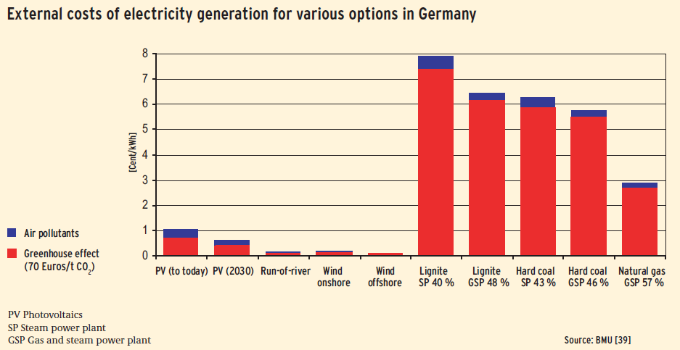

***Figure 8 - External cost of electricity generation for fossil and renewables options***

(Source: BMU, 2009)

As figure 8 shows, conventional electricity generation causes significantly more environmental damage than electricity from renewable energy sources. These so-called external costs are not yet incorporated into the electricity prices as required by the polluter-pays-principle. According to a study carried out on behalf of the BMU[1], greenhouse gas emissions play a key role: The current best estimate of the cost of climate damage arising from such emissions is around 70 Euros/t CO2. Part of this is already taken into account in the electricity price via emissions trading within the EU. In addition, health and material damage caused by air pollutants and agricultural revenue losses are important.

External costs for electricity generated from hard coal and lignite – even allowing for modern technology – amount to 6 to 8 cents/kWh. For modern gas and steam plants, the external costs are still approximately 3 cents/kWh. By contrast, electricity generation from renewable energies causes comparatively minor external costs.[2]

In a competitive market, the existence of external costs will cause too much goods to be produced and consumed in terms of overall costs and benefits to society. The price per gallon of gasoline, for instance, may include the cost of production but not the expense of treating respiratory illnesses from breathing polluted air or the repair bill from acid rain damage. Nor does it cover the cost of rising global temperature: more destructive storms, damage to agricultural productivity, or the relocation of millions of refugees forced from their homes by sea level rise. In fact, in some cases, the indirect (or external) costs of some products have become far larger than the market price. As the market is organized in the current situation and if there are no ecological taxes on gasoline, the motorist burning the gasoline do not bear these costs.

One way to change this unsustainable development is to incorporate the indirect cost into market prices by restructuring taxes (without raising them overall). If we can get the market to tell the truth, then we can avoid being blindsided by faulty accounting systems that lead to bankruptcy. As Oystein Dahle, former Vice President of Exxon for Norway and the North Sea, has pointed out: "Socialism collapsed because it did not allow the market to tell the economic truth. Capitalism may collapse because it does not allow the market to tell the ecological truth." (Brown, 2009)

**4.** **The Energy Subsidies**

In most countries, energy is taxed mostly because of its external effects on environment (see Figure 1). In few countries including Iran, however, energy is subsidized[3]. The objectives of energy subsidy in these countries may fall into the political or development support category. They subsidize energy to provide inexpensive input to energy intensive manufacturing industries enabling them to develop and compete in international market. As the most developing countries experience show, the development or political support programs have rarely been able to achieve their original objectives, since they have run for much longer periods than was necessary, changed their priorities, and deviated from original objectives.

Figure 1 shows that in some energy rich developing countries, including Iran, gasoline and diesel prices are very low – lower than the production cost (cost for crude oil and cost of refinery). In 2008, the gasoline price of US $0.53 per liter, without any taxes, was required to cover the average cost of production (GTZ 2008). Consequently, prices below this level represent subsidised prices and tend to lead to distortions in the economy. On the other hand, reducing the subsidies for gasoline and diesel would have a significant effect on demand, especially in the long term. In the transport-sector this would lead to

* demand shift to more efficient cars and on the long run more investment to built or import higher efficient cars
* changes in the driving behaviour
* changes in modal split: more people would use public transport or bicycles
* less investment needed for new streets and refineries
* less import of gasoline and diesel or more export because of lower domestic consumption
* less environmental damages.

Those are the reasons, why in many countries (OECD-countries, transition countries and developing countries) energy price subsidies have been eliminated or reduced for the last decade.



***Figure 1: Gasoline Prices across Countries, Source GTZ (2008)***



***Figure 2: Gasoline prices in different countries in November 2008.***

Source: GTZ (2009)

Figure 2 also shows that Iran still has one of the lowest prices for gasoline in the world. In November 2008, the price per litre gasoline was only $ 0.10 for consumption below 120 litters per month per car. The price for gasoline above this quota was $ 0. 53.

In market economies, prices should at least reflect fairly accurately the supply costs. For our example (gasoline) that means that the price should not only include the costs of crude oil and refinery, but it should also include the costs for investments on new roads and the road maintenance, as well as the costs for environmental damages. That is why in many developed countries, gasoline is highly taxed. The gasoline tax is to cover the external costs like environmental damages, incidents and the costs of the control-system, as well as to help balance the government budgets, particularly when other government revenues sources are limited (European Commission, 2005). Figure 3 shows the situation of costs, prices and taxes in Germany.



***Figure 3: Price components in Germany in the year 2007***

*Source: Mineralölwirtschaftsverband, July 2008*



***Figure 4: Social Benefits of a Gasoline Price Reform in Iran***

Figure 4 shows the situation in Iran today: The price for fuel and gasoline are extremely low and heavily subsidized. If the price of fuel rises to the border price, the demand for fuel will decrease. The difference between fuel demand x1 and x2 could be sold at the world market at the border price. The additional income, (x1-x2)*(border price-price in Iran), could be used for additional investment or imports from outside the country. To calculate the potential revenues due to lower consumption in Iran, we need gasoline price elasticities for different income groups. The estimates of price elasticities for gasoline in Iran are generally very low as they are based on the very low prices in the past. Those elasticities are not reliable for predicting consumer behaviour in future when prices are high. In this study, we use estimates by Blooki (2007), which uses the most recent data that includes higher prices and estimates the elasticities for different income groups. Table 1 shows that price elasticities decrease with income, that is, given the same price change, the lower price groups would cut their consumption more proportionally than the upper income groups. Overall, if price rises by 1 percent, urban households would cut their gasoline consumption by more than a quarter million liter per day and rural households by about 185,000 liter per day. If price rises to the current border prices, ($0.40/liter), the total household consumption will decline by 1.37 million liter per day. This translates to more than 250 million dollars savings because of lower imports. In addition, government would receive about $7.5 billion extra revenues because of higher gasoline prices in domestic market.

***Table 1 - Change in Gasoline Consumption Due to a Change in Gasoline Price***

|  |  |  |  |  |  |  |  |
| --- | --- | --- | --- | --- | --- | --- | --- |
| Income Group | | Elasticitya | Change in Consumption, liter/day (1)b | | | | Change in Consumption, liter/day(2) |
| Urban | Rural | | Total |
|  | |  |  |  | |  |  |
| low | 0.92 | | 64425 | | 52017 | 116442 | 349325 |
| mid | 0.76 | | 98267 | | 60171 | 158438 | 475314 |
| up | 0.55 | | 110951 | | 72412 | 183363 | 550088 |
| Total |  | | 273643 | | 184599 | 458242 | 1374727 |
| a. Gasoline demand price elasticities are from Blooki (2007).  b. Total gasoline consumption was 66.8 milion liter per day in 2007, which is divided by 60-40 ratio between urban and rural households. The non-household gasoline consumption is not considered. The first change in consumption is for one percent change in gasoline price, but the second (last column) is for 300 percent change ($0.40/liter)  Source: Authors calculations | | | | | | | |

**5. Consequences of subventions in Iran**

**5.1 Energy Subsidies Problems**

The continuous energy subsidies program in Iran has caused various economic and social problems some of which are listed below.

* Increasing energy consumption and waste
* Reducing incentives for using more efficient technologies and innovation
* Degrading environment by lowering quality of air in urban areas[4]
* Placing a heavy burden on government budget, contributing to budget deficit by increasing direct payments as well as foregone income through higher oil exports[5]
* Cross-border smuggling of oil products to neighbouring countries
* Exacerbating the unfair distribution of income by allocating more subsidies to rich people.

Although government has raised the energy prices for the past 15 years, the real energy prices have decreased because of higher inflation rates. Since the start of the third FYDP, energy prices have risen on average by only 10 per cent per year, but the average inflation rate in this period has been more than 15 percent. The fourth FYDP called for a more aggressive measure to reform the energy market, that is, to increase the gasoline prices to the border prices. However, the new elected government and parliament did not implement the plan and froze the fuel prices in 2006 and 2007.

The subsidy problem is more prominent in the case of gasoline consumption, which receives about one third of the total energy subsidies. Gasoline is sold below the market price at around 10 cents per litre, which is about one fourth of the border price and about one fifteenth of the European prices. The very low price of gasoline has encouraged high level of gasoline consumption. The growth rate of gasoline consumption has averaged 10 percent annually over the period 2001-2007, and the consumption reached about 70 million litres per day in 2007. It has also led to a high concentration of air pollutants along with other social and economic problems. In response to a rapid growth in gasoline consumption, government drew on the Oil Reserve Fund to import about 40 per cent of domestic consumption in 2007. Iran is now the second biggest gasoline importer in the world after United States. In June 2007, government instituted a gasoline rationing system to curb the rapidly growing consumption. In the new system, each private passenger car would receive 30 liters gasoline per month at the fixed price of 1000 rials or about $0.11 per litre. The rationing scheme did not have any significant effect on domestic consumption, but it apparently reduced the amount of gasoline smuggled to the neighbouring countries. The rationing system later allowed for consumption to exceed the quota at the price of 4000 rials ($ 0.44) per litre. The quotas were reduced to 80 litres per passenger car in 2010 and expected to be removed in part because of gasoline import restrictions imposed on Iran.

**5.2 Macroeconomic Effects of Price Reform**

The energy price reform in Iran is imminent as the prolonged subsidy program in the energy sector has led to high level of distortions in the economy and imbalances in different sectors, including government budget. If the current policy of subsidizing energy consumption continues, government has to cut oil exports or to import more gasoline in response to the growing domestic demand. This will have an extra pressure on government budget leading to higher inflation and balance of payment deficit, and lower growth. Government has decided to finally tackle the growing problem in the energy sector by reforming energy pricing system and cutting back the subsidies. However, there are many challenges the policy makers and the society at large have to face regarding the price reform policy. There is a need for a clear road map for the price reform policy which shows what type of energy subsidies would be removed, by how much and how. Moreover, the macroeconomic impacts of price reform on inflation, economic growth, unemployment, and balance of payments should be studied and dealt with carefully. Government also needs to have a plan on how to spend the additional revenues that will be generated by removing subsidies. The plan should identify the more vulnerable social groups, among both consumers and producers, who would suffer the most under the price reform scheme, and lay out the details on how to compensate for their loss of income. In the following, we review some of the macroeconomic impacts of the energy price reform. Throughout our analysis, we define subsidies as government direct transfers to consumers or producers, which appear in government budget, as well as the opportunity costs or implicit subsidy arising from the difference between domestic and border prices. The latter is the most important part of the energy subsidy in Iran as the differences between the domestic prices and the border prices are highly significant.[6]

**Government Budget**

For the past 40 years, the government budget has always had deficits. The only exceptions are the period 1993-1995 and 1999 when government devaluated rial and reported its revenues with the new exchange rates. Subsidies on basic goods have traditionally been one of the major government outlays comprising more than 12 percent of the budget. The budget has also includes energy subsidy (fuel and gasoline), which has been increasing from 2 percent to more than 8 percent of the budget. If we include the implicit subsidy, the share of total energy subsidies of total budget would amount to between 20 to 40 percent, depending on oil prices. Reducing or removing direct subsidies will alleviate the budget deficit problem. Price reform will also generate significant revenues for government by selling energy careers at border prices, which are at least four times greater than the current domestic prices. Depending on the international energy prices, the additional government revenues from energy price reform is estimated at $100 to $400 billion in 2010. The final effect of price reform policy on government budget will depend on fiscal policy as to how spend additional revenues. If government does not expand its spending, the budget deficit will be reduced and government will be able to pay back its debt to central bank. However, if the additional revenues are spent on compensation and welfare programs, the budget deficit will continue.

There are other channels through which budget deficit might be affected. One possibility is the wage adjustment due to the inflationary effects of price reform, which will contribute to a higher level of deficit. The second channel is the exchange rate changes due to balance of payment imbalances. The higher energy prices will weaken the industries position in the international markets lowering exports. If government devaluates exchange rate to support exports, its oil exports revenues will increase reducing budget deficit. The final effect of this channel will depend on the government import expenditures which will also rise.

**Inflation**

Removing energy subsidies will have strong effects on prices, exchange rates, and cost of living. Consumers will have to pay higher prices for different energy carriers, non-energy goods whose prices will increase to offset the increase in their energy costs, and all other goods whose costs in turn will be affected by energy price rises. There are some studies which predict the inflationary effects of the energy price reform. As Table 2 shows, these effects vary from 1.47 percent (Komijani, 2004) to 103 percent (Manzoor, 2004). The huge variations in estimation of inflationary effects of energy price reform are due to the models used (IO, SAM, and CGE) and the assumptions made. The lower end of the inflationary effects are based on the assumption that price reform policy will be implemented gradually in four to five years, whereas the higher end of the effects assume that price changes will materialize once. Moreover, the types of energy careers subject to price changes are different in the studies.

One of the common shortcomings in the studies of inflationary effect of energy price reform is that they are static leading to unrealistic implications, which generates unsubstantiated fears among policy makers and the society. A rise in energy prices will not have a continuous inflationary effect, since it will only increase the aggregate price level in the short-term. The inflation rate will return to its past trend after the economy adjusts to its new equilibrium level. The major source of inflation is government and central bank policies on budget deficit, money supply, and exchange rates. If government adopts non- or anti-inflationary fiscal and monetary policies during the energy price shock, the economy will not necessarily experience a higher inflation rate. In fact, the experiences of energy price reform in some developing countries suggest that inflation rate may even be lower after the reform. For instance, while a rise in diesel and kerosene prices in Indonesia and Turkey led to higher inflation rates by 0.6 and 16 per cent, the inflation rates in Malaysia and Zimbabwe were lower by 80 per cent and 40 per cent, respectively, after two year of price change (Hope and Singh,1995).

**Table 2- The inflationary Effects of Energy Price Reform in Iran \***

|  |  |  |  |
| --- | --- | --- | --- |
| **Study** | **Inflationary effect (%)** | **method** | **Assumptions** |
| Davoodi, Ahmad (2004) - MPO | 2.31 – 5.84 a | 4th FYDP model | gasoline, oil gas, and fuel oil |
| Komijani (2004) - CBI | 1.47 – 26.5 b | IO | gasoline, gas oil, and fuel oil |
| Komijani (2004) - CBI | 2.26-29.50 b | ECGE | gasoline, gas oil, and fuel oil |
| Komijani (2004) - CBI | 2.35 | IO | 1. All energy careers  2. liquid gas, natural gas, and electricity will change with inflation rates |
| Komijani (2004) - CBI | 4.15 | ECGE | 1. All energy careers  2. liquid gas, natural gas, and electricity will change with inflation rates |
| Manzoor (2004) | 103 | IO | 1. 10 percent increase in all energy careers  2. 2002 data |
| Sharifi, Sadeghi, and Abedin Ghasemi (2008) | 45.62-54.38 | IO | 1.All energy careers  2. all three scenarios: 10%, 35%, and 65% energy price increase |
| Tasdighi (2008) - PRC | 10.5- 48.6c | IO | 1. all energy careers  2. One time price change |
| Parvin and Banooie (2009) | 38 | SAM (80) | Removing direct energy and non-energy subsidies |
| Parmeh (2005) | 35.6 | SAM | All energy careers |
| Khiabani (2008) | 35 | CGE-SAM | All energy careers |
| World Bank (1999) | 40 | IO | All energy careers |
| * Price reform is defined as increasing prices to the border prices.  a. With and without wage and interest adjustments  b. Gradual price change (in 5 years) and one time price change  c. Gradual price change (in 5 years) and one time price change  MPO= Management and Plan Organization  CBI = Central Bank of Iran  PRC = Parliament Research Center | | | |

**Income Distribution**

One of the main objectives of the subsidy programs is to redistribute income from rich to poor. However, the objective is not usually achieved in practice, particularly when subsidy applies to goods whose consumption increases with income and all income groups receive the same amount. Energy subsidy is one example that benefits rich more than poor as the latter consumes more (subsidized) energy than the former. The energy price reform will increase energy prices and will decrease consumption. The effect on household’s expenditures will depend on the price elasticity of demand. If elasticity is low, energy expenditures will increase, which means that, given income, households will have to cut consumption of other goods or to cut savings. Table 3 shows that the energy price index has increased on average by 13 percent and the non- energy price index by 16 percent for the period 2001-2008. The share of energy expenditures of total expenditures by household have been declining from 4 percent to 2.7 percent.

***Table 3 - Energy and Non-energy Price Changes and Household Energy Expenditures Shares***

|  |  |  |  |  |  |  |
| --- | --- | --- | --- | --- | --- | --- |
| Energy Expenditures Share* | Price Change Difference | Non- energy  Price Change | Non- energy Price Index | Energy Price Change | Energy Price  Index |  |
| 0.040 |  |  | 86 |  | 93 | 2001 |
| 0.040 | 0.08 | 0.16 | 100 | 0.08 | 100 | 2002 |
| 0.044 | -0.17 | 0.15 | 115 | 0.32 | 132 | 2003 |
| 0.042 | -0.12 | 0.15 | 132 | 0.27 | 168 | 2004 |
| 0.038 | 0.08 | 0.11 | 146 | 0.03 | 173 | 2005 |
| 0.032 | 0.12 | 0.12 | 164 | 0.01 | 174 | 2006 |
| 0.030 | -0.02 | 0.18 | 195 | 0.20 | 209 | 2007 |
| 0.027 | 0.24 | 0.26 | 245 | 0.02 | 213 | 2008 |
|  | 0.03 | 0.16 |  | 0.13 |  | Average |
| * Energy expenditures include expenditures on electricity, natural gas, and gasoline.   Source: Central Bank of Iran (price index), Statistic Center of Iran (Household Budget Surveys), and the author’s calculation | | | | | | |

Figure 5 also shows the trend for prices and energy expenditures shares. As the figure shows, there is a lag in changes in energy expenditure shares as prices change, which indicates that it takes time for households to adjust their consumption.

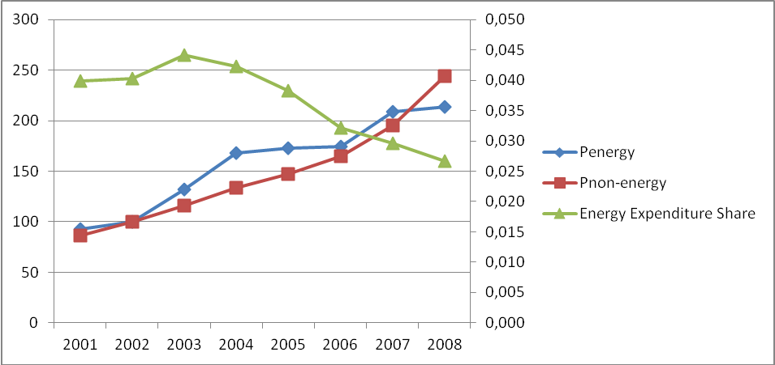

***Figure 5 - Energy and Non-energy Price and Energy Expenditures Shares (2001-2008)***

Source: Authors’ calculation

The change in expenditures will vary in different income groups depending on their preferences as well as price and income elasticities of demand for energy. As Figures 6 and 7 show, the energy expenditures shares changes inversely with the level of income in both urban and rural households. They also show that changes in expenditures are more pronounced in lower income groups than higher income groups. Based on the trends of the energy expenditures shares when energy prices have been rising, we can conjecture that lower income households will be more severely affected by energy price reform.

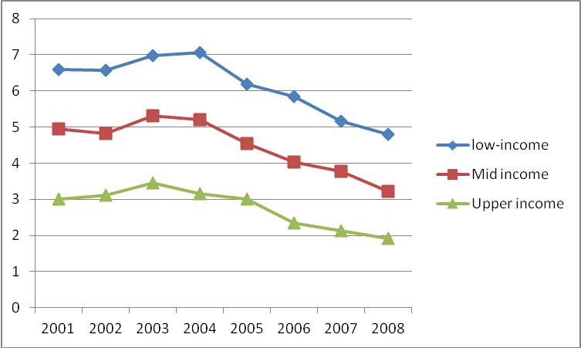

***Figure 6 - Shares of Urban Household Energy Expenditures of Total Expenditures***

Low income includes the first three income deciles in the Household Budget Survey, mid income the fourth to eights deciles, and the upper income the last two deciles.

Source: Household Budget Surveys, Statistic Canada, and the author’s calculation

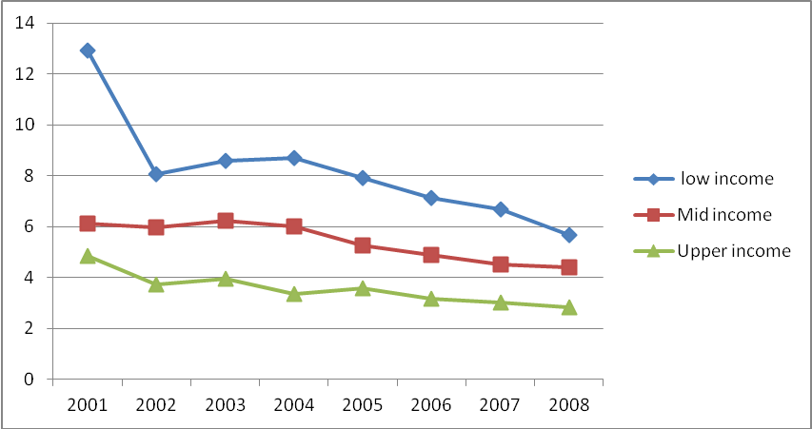

***Figure 7 - Shares of Rural Household Energy Expenditures of Total Expenditures***

Low income includes the first three income deciles in the Household Budget Survey, mid income the fourth to eights deciles, and the upper income the last two deciles.

Source: Household Budget Surveys, Statistic Canada, and the author’s calculation

The differences in energy expenditures in different income groups are more evident in Table 4. Overall, total income of higher income groups is 4.43 times more than that of lower income groups in urban areas and the energy expenditures increase with the level of income. Specifically, higher income groups spend on average 1.77 times more than lower income groups on energy. The ratio is much higher in gasoline followed by electricity and natural gas. The levels of income and energy expenditures are generally lower in rural areas than urban areas, but the structure is rather similar. However, the disparity in total energy expenditures between income groups is higher among rural households than urban households; upper income households spend 2.05 times more than lower income households on energy. Akin to the urban households, difference is higher in gasoline expenditures. It is also important to note that the lower income urban households are poorer than mid and upper income rural households and spend less on energy.

***Table 4 - Energy and Non-energy Expenditures by Household Income Groups- rial (2008)***

|  |  |  |  |  |  |  |  |  |  |  |  |  |
| --- | --- | --- | --- | --- | --- | --- | --- | --- | --- | --- | --- | --- |
|  | Total Income | | Electricity | | Natural gas | | Gasoline | | Total Energy | | Non-energy | |
| Urban |  | |  | |  | |  | |  | |  | |
| Low income | 48779260 | | 678841.6 | | 747078 | | 914618.2 | | 2340538 | | 46438722 | |
| Mid income | 97047567 | | 843181.6 | | 802876.3 | | 1482346 | | 3128404 | | 93919163 | |
| Upper income | 215912279 | | 1226028 | | 905649.5 | | 2021587 | | 4153264 | | 211759015 | |
| ratio (up/low) | 4.43 | | 1.81 | | 1.21 | | 2.21 | | 1.77 | | 4.56 | |
|  |  |  | |  | |  | |  | |  | |
| Rural |  |  | |  | |  | |  | |  | |
| Low income | 35988255 | 527484.1 | | | 820764.2 | 689290.4 | | 2037539 | | 33950716 | |
| Mid income | 67412831 | 749996.1 | | | 1031789 | 1189456 | | 2971241 | | 64441590 | |
| Upper income | 146854021 | 1027129 | | | 1481349 | 1672193 | | 4180671 | | 142673351 | |
| ratio (up/low) | 4.08 | 1.95 | | | 1.80 | 2.43 | | 2.05 | | 4.20 | |
| Low income includes the first three income deciles in the Household Budget Survey, mid income the fourth to eights deciles, and the upper income the last two deciles.  Source: Household Budget Surveys, Statistic Canada, and the author’s calculation | | | | | | | | | | | |
|  |  | |  | |  | |  | |  | |  | |

The above figures indicate that although the level of expenditures on energy is lower among lower income households, their shares of total expenditures are higher as their income level is disproportionally lower. They also show that the difference between energy expenditures in different income groups is more for gasoline than other energy careers. We therefore, can conclude that lower income groups will be affected the most by the energy price reform, particularly when it applies to gasoline.

Government can use the additional revenues generated by removing subsidies to compensate low income households for higher energy prices. Since the levels of expenditures on energy vary with the level of income, i.e, higher income groups spend more on energy than lower income groups, equal direct payments to all households will redistribute income from rich to poor. This will be more evident in the case of gasoline price change as the disparity in energy expenditures between rich and poor is the highest in gasoline. Table 5 shows more explicitly that the shares of energy subsidies received by higher income groups are much greater than those by lower income groups. Specifically, the gasoline subsidy share received by urban households is 20 percentage points greater than that by rural households and upper income groups’ share of subsidy is about 8 times greater than lower income groups. The ratio is much higher in the case of fuel oil, which is used mostly in rural areas. Therefore, the removal of energy subsidies and transferring the proceedings to all income groups equally will adjust income distribution in favour of lower income groups.

***Table 5 - The Share of Income Groups of Energy Subsidies, 2007***

|  |  |  |  |  |  |  |
| --- | --- | --- | --- | --- | --- | --- |
|  |  | Lower Income* | Mid Income | Upper Income | Total | ratio (up/low) |
| Gasoline | Urban | 4.7 | 17.4 | 37 | 59.1 | 7.87 |
|  | Rural | 3.4 | 12.3 | 25.2 | 40.9 | 7.41 |
|  | Total | 8.1 | 29.7 | 62.1 | 100 | 7.67 |
| Fuel Oil | Urban | 0.4 | 1.5 | 4.9 | 6.8 | 12.25 |
|  | Rural | 2.6 | 26.4 | 64.1 | 93.1 | 24.65 |
|  | Total | 3 | 27.8 | 69.1 | 100 | 23.03 |
| Liquid Gas | Urban | 5.4 | 5.9 | 3.2 | 14.5 | 0.59 |
|  | Rural | 18.1 | 35.1 | 32.3 | 85.5 | 1.78 |
|  | Total | 23.5 | 41 | 35.5 | 100 | 1.51 |
| Kerosene | Urban | 2.9 | 4 | 2.1 | 9 | 0.72 |
|  | Rural | 13.2 | 35.5 | 42.3 | 91 | 3.20 |
|  | Total | 16.1 | 39.5 | 44.5 | 100 | 2.76 |
| Gas Oil | Urban | 14.4 | 0 | 0 | 14.4 | 0.00 |
|  | Rural | 7.4 | 36.3 | 41.8 | 85.5 | 5.65 |
|  | Total | 21.8 | 36.3 | 41.8 | 100 | 1.92 |
| * Low income includes the first three income deciles in the Household Budget Survey, mid income the fourth to eights deciles, and the upper income the last two deciles.  Source: Energy Balance (2008) and author’s calculations | | | | | |

Income redistribution from rich to poor will have implications on production and price levels as well. Since marginal propensity to consume is rather higher in low income groups, most of the additional income received from government will be spent immediately leading to a higher aggregate demand and therefore prices. On the other hand, since the energy elasticity in rich is low, higher prices will lead to lower savings rather than lower consumption.

**Production**

Removing energy subsidies will increase energy costs in the industry and transportation sectors. The effect will vary depending on the specific energy intensity in different industries. The higher energy intensive industries and businesses will have to bear higher costs of energy and adjust the production and employment levels accordingly. In short run, this may prove difficult, particularly for industries which have been heavily subsidized and supported for the long period. In the medium and long run, the industries will have to eventually change their technologies and production processes to lower their energy intensities. Otherwise they cannot survive.

Using the large manufacturing industries data, Mousavineek and Tootoonchi Maleki (2009) show that the direct production cost of manufacturing industries will almost double on average if the energy prices are adjusted based on the OPEC oil price in 2009 ($78 per barrel). Khiabni (2008) also shows that the price reform will lead to production cuts in manufacturing industries and mining by 2 to 8 percent. The increase in cost in industries and the production cut would vary in different industries depending on their energy intensities and demand elasticities. For instance, cement, aluminium, and steel industries will experience the highest costs followed by petrochemical, textile, and copper industries. Moreover, basic metals, chemicals, textiles, paper, and food industries will cut their production the most. How much of the increase in production cost these industries can pass on output prices depend on demand elasticities. If the price elasticity of demand is very high (e.g. luxury goods), the producers have to bear the entire costs, and if the price elasticity is very low (e.g. necessary goods), the producers will be able to pass the entire costs to consumers. The industries most affected by the energy price reforms are those whose products are used by other industries such as auto and construction, which do not have very low demand elasticity. Therefore, the higher energy costs will be shared by both producers and consumers. In the long run, the industries with high demand elasticity are expected to take more aggressive measures in using more energy efficient technologies. Auto industry will hit more because of both direct and indirect effects of the energy price rise. The energy intensity in the industry and its output are high. As the price of input materials like steel rises, the price of car will have to increase, which will have an adverse effect on its demand. Moreover, the higher gasoline price will also have an adverse effect on demand for car. The industry will therefore have a golden opportunity to undergo dramatic technological changes and to produce more efficient cars[7].

To alleviate the adverse effects of the energy price reform on production and employment in the short run, government needs to have a compensation plan for producers and workers who lose their jobs. Furthermore, part of the additional revenues generated by the energy price reform can be allocated to set up and support employment training programs, R&D investment, and investment in advanced and efficient technologies. The use of better technologies in industries will increase the energy efficiency leading to lower quality adjusted prices.

**Balance of Payments**

Rising energy prices will increase the costs of domestic products, particularly in the energy intensive industries, weakening their position in the international market. This will likely lead to a change in trade balance as exports will decline and imports will increase. On the other hand, the energy price reform will curb the domestic energy consumption freeing oil resources for more exports and improving the balance of payments. The net effect on balance of payments will depend on the import/export elasticiteis and the magnitudes of the two opposing effects above as well as the exchange rate and trade policies. Energy price reform will put pressure on the value of rial as exports decline and imports rise. If the current policy of supporting rial continues, non-oil trade deficit will increase. However, if exchange rates are allowed to change, production may not suffer and exports may not decline. The downside of this policy is, however, an increase in price level as imports become more expensive.

**6. Conclusion**

Energy price reform is inevitable in Iran, but it may have striking adverse economic and social impacts, should it not be done properly. Therefore, it is imperative to study all various effects using economic models that take into account all different sectors of the economy and would analyze alternative scenarios. The outcome of such detailed studies would help policy makers to foresee the potential benefits and challenges and thus design appropriate policies that would capitalize on advantages and alleviate the adverse effects.

The important effects and implications of the energy price reform are as follows.

* The higher energy prices will increase price levels in the economy. This will decrease the purchasing power and, therefore, welfare of consumers and will increase the production costs, which will contribute to higher prices.
* The price effects are not symmetric across households and industries. Lower income groups will be affected more than higher income groups, and energy-intensive industries will be affected more severely.
* The short run inflationary effects of energy price reform is stronger if it is done once than when it is done gradually. In any case, the inflationary effect will depend on the fiscal and monetary policies and inflation expectations. If government adopts expansionary policies following the energy price reform, the short run shift in price will turn into high inflation rates. For instance, if government adjusts wages or increases transfer payments more than the level predicted by the price reform plan by borrowing from central bank, inflation rate will increase. Inflation will increase if people do not trust in government policy due to either miscommunications, lack of transparency and ability, or political tensions.
* Energy price reform will have a drastic effect on manufacturing industries. In the long run, industries will have to undergo dramatic technological changes to reduce their energy intensities. In the short run, however, higher energy costs will cause industries with high energy intensity and older technologies to scale down or shot down increasing unemployment.
* The exchange rate policy will have an important effect on production, employment, and price levels. The energy price reform will lead to a depreciation of rial which will alleviate the negative effects on exports, production and employment. It will however, contribute to higher price levels. The continued controlled exchange rate policy, however, will exacerbate the negative impacts on exports, production and employment.
* Government can use extra revenues from the higher energy prices to alleviate the short run negative impacts of the price reform. It can allocate revenues to lower income groups and people who lose their jobs, and to support vulnerable industries. It can also make an investment on R&D to help industries adopt more efficient technologies.
* The price reform is an important economic change that will affect all sectors of the economy. Since the reform will reallocate resources and income, it will cause social tensions among various groups in the short run. Therefore, the success of such an important reform will primarily depend on how society will participate and cooperate. If there is trust between people and government, that is, if society believes that government is able to implement such a critical reform and that the reform will benefit everybody in the long run, it may be willing to sacrifice in the short run. This requires a transparent plan and effective communication on the government side.

**References**

BMU 2009: Renewable Energy Resources in Figures, Berlin, Status June 2009

Blooki, Mona (2007), The Effects of Gasoline Price Changes on Households Basic Goods Consumption Shares, MA thesis, Faculty of Economics, University of Allameh Tabatabaie

Brown, L.R.: Plan B 4.0: Mobilizing to Save Civilization, 2009

Iran Energy Balance, Ministry of Energy, various years

European Commission 2005: ExternE, Externalities of Energy. Methodology 2005 update. Directorate-General for Research Sustainable Energy Systems.

GTZ 2008: International Fuel Prices, 6th Edition - Data Preview

GTZ 2007: Environmental Fiscal Reform in Developing, Emerging and Transition Economies: Progress & Prospects, Documentation of the 2007 Special Workshop hosted by the Federal Ministry for Economic Cooperation and Development (BMZ) and the Deutsche Gesellschaft für Technische Zusammenarbeit (GTZ) GmbH

Hope, Einar, and Blabir Singh (1995), Energy Price Increases in Developing Countries: Case Studies of Colombia, Ghana, Indonesia, Malaysia, Turkey, and Zimbabwe, Policy Research Working Paper, 1442, World Bank.

Institute for European Environmental Policy 2007: Reforming Environmentally Harmful Subsidies, March 2007

Khiabani, Naser (2008), An Analysis of an Increase in Energy Prices using a CGE Model, Energy Economics Studies, 5, 16, 1-34.

Komijani, Akbar (2004), The Economic Effects of Replacing Subsidies with Cash Payment on Inflation, Proceedings of Economics of Subsidy, Imam Sadeqh University, 475-488.

Manzoor, Davood (2004), The Effects of Removing Energy Subsidies on Different Income Deciles. Proceedings of Economics of Subsidy, Imam Sadeqh University, 665-987.

Moosavinik, Hadi, and Saeed Tootoonchi Maleki (2009), A Review on the Subsidy Reform Legislation and Its Economic Effects, Parliament Research Center, 220, 10004.

Moshiri, S., Lechtenböhmer, S., Seifried, D., Panjeshahi, M.H., Atabi, F., Jahangard, E., Massarat, M., Heidari, Q. and Supersberger, N. (2009): Energy Scenarios for Iran, German-Iranian cooperation project, Wuppertal Institute for Climate, Environement, and Energy, and Iran Energy Association.

Parvin, Sohila, and Aliasghar Banouni (2009), An Analysis of Income Distribution Changes after Basic Goods Subsidy Removal, in press.

Sharifi, Alimorad, Mehdi, Sadeghi, and Abedin Ghasemi (2008), A Study of Inflationary Effects of Energy Subsidy Removal, Economic Research, No. 8, 4.

Tasdighi, Behrouz (2008), A Review on Subsidy Reform Legislation, Parliament Research Department, Economic Studies, Macroeconomics Group.

The International Bank for Reconstruction and Development/World Bank: Environmental fiscal reform May 2005

World Bank (1999), Economic Aspects of Increasing Energy Prices to Border Price Levels in Islamic Republic of Iran, Middle East and North Africa Region

World Energy Council 2008: Energy Energy Efficiency Policies around the World: Review and Evaluation

1. DLR 2006
2. The construction and disposal of the plants are included in these calculations. BMU 2009
3. As Figure 1 shows, there are 12 countries in the world in which the retail gasoline price is lower than the crude oil prices in the world market. These countries are all energy rich countries in Middle East, Africa, and South America.
4. The fuel oil subsidies may have positive effect on environment if it discourages the deforestation in the rural areas. The size of this subsidy, however, would be very small given the small rural population and their low consumption level.
5. OPEC quotas are for total production not exports. Therefore, Iran can always export more oil and earn foreign income without violating its quota, should its domestic consumption reduces.
6. The direct subsidy for gasoline and oil was about $2 billion and the indirect (implicit) subsidy for all energy careers $18 billion in 2004.
7. The US auto industry faced with the same challenge during the first oil shock in 1973 and under the government regulation was able to produce more efficient cars.