Final Draft
German-Iranian Co-operation VI
“Development of three cornerstones for a sustainable Energy future in Iran “

Work package 1.
Feed-in laws and other support schemes
in international perspective

Wuppertal, 31.07.2010

Authors:

WI:
Dr. Stefan Lechtenböchmer
Magdolna Prantner
Dieter Seifried
Dr. Nikolaus Supersberger
IEA:
Dr. Saeed Moshiri
Dr. Farideh Atabi
Dr. Mohamad Hassan Panjeshahi

With collaboration of
Laura Führer
Ali Haddad Rahmati

Wuppertal Institut für Klima, Umwelt, Energie GmbH
Döppersberg 19
D-42103 Wuppertal
Table of content
List of Figures 3
List of Tables 3
1. Introduction 4
2. Instruments for the support of renewable energies 4
2.1. Why is government support needed? 4
2.2. Feed-in tariff systems 7
2.3. Quota system and tradable green certificates 8
2.4. Comparison of feed-in and quota systems 9
3. International Experiences from developing countries 11
3.1. Successful example: India 11
3.2. Unsuccessful Example - Algeria 15
4. Iranian Development and Situation 17
4.1. Rationales for Renewable Energy Investment in Iran 17
4.2. Renewable Energy Development Objectives 18
4.3. Renewable Energy Potentials 18
4.4. Renewable Energy Organizations 23
4.5. Renewable Energy Development Act 25
4.6. Power Generating Plant Applications 25
5. SWOT analysis of the Renewable Energy Organisation in Iran 26
6. Renewable Energy Challenges in Iran 28
7. Suggestions for the Improvement of the Feed-in 29
Appendix 1: Feed- in – laws in Iran 31
Appendix 2: Germany: Case studies wind power and solar energy 34
The federal feed-in law 34
The German Renewable Energy Sources Act (EEG) 35
Status and development of the German wind energy industry 36
Incentives for German wind energy investors 37
Solar energy utilisation and industry development 38
Incentives for the PV industry in Germany 39
Macro-economic effects of the EEG: Role on world markets and employment 40
Renewable expansion path: Development of contribution and economic costs 41
Appendix 3: Spain: Case studies wind and solar power 43
Development of the Spanish feed-in system 43
Wind power 45
Solar energy: favourable conditions in Spain 47
Costs and benefits of the Spanish support scheme 48
Annex 4: German feed-in tariffs 49
Annex 5: Spanish support schemes 52
References 53
List of Figures

Figure 1. Comparison of prices for wind-generated electricity per kilowatt in feed-in and quota systems in various countries (Grotz, Fouquet, 2005) 9
Figure 2: Installed capacities in countries with feed-in and quota systems, 2004. (Grotz, Fouquet, 2005) 9
Figure 3 Growth of wind power in India. (M. Carolin Mabel , E. Fernandez) 11
Figure 4 Current position of the Indian wind energy sector (Renewable Energy Policy Network for the 21st Century, Global Status Report) 12
Figure 4: Iran Renewable Energy Organization (SUNA) 19
Figure 5: Renewable energy sources as a share of energy supply in Germany. (BMU, 2009) 35
Figure 6: Installed wind energy capacity in Germany 1990 – 2008 (Dewi, 2009) 36
Figure 7: Growth of wind power generation capacity in Germany: and total capacites (BWE, 2009). 37
Figure 8: Growth of PV capacity in Germany: annually installed and total capacites. (BSW, 2009) 38
Figure 9: Job growth of the German renewable energy industry. (BMU, 2009) 40
Figure 10: Additional costs of the German renewable energy expansion path in all sectors, Lead 41
Figure 11: Growth of electricity generation capacity from renewable energies in Spain in Megawatt. (AHK, 2009) 43
Figure 12. Growth of wind power capacity in Spain (AEE, 2009) 44
Figure 13: Spanish support system for wind power (2008) (IEA, 2009) 45
Figure 14: Cumulative PV power installed (in MW) in Spain from 2000 to 2008 and forecast 2009 – 2013 (EPIA, 2009) 46

List of Tables

Table 1: Supporting Programs of Renewable Energies in Developing Countries 5
Table 2. Target capacities for solar energy (MNRE, 2010). 11
Table 3: Cost Structure in Conventional Power Plants versus Renewable Energy Power Plants 16
Table 4: Electricity Generation by Renewable and Non Renewable Sources (GWh)- BAU Scenario (2005-2030) 18
Table 5: Geothermal Potentials in Iran 21
Table 6: Basic data on renewable energy potentials in Iran; Source: DLR (2005) 22
Table 7: Summary of Economic Renewable Electricity Supply Potentials in Iran, TWh/y Source: DLR (2005) 22
Table 8: Public Spending per Tonne of CO2 Emissions Avoided and per Job Created under the Renewable Energy Plan 2005-2010 (IEA, 2009) 47

1. Introduction
The new global approach to the environment and rising concerns over energy scarcity and security have led developed countries to increase investment in renewable energy sources as an alternative to conventional energy. Renewable energy development helps tackle climate change, environmental pollution and energy security risks. Furthermore, renewable energy technologies are becoming increasingly important for countries’ economic development and job creation.
Governments across the developed world are increasingly supporting activities in research and development that will advance technologies to enable alternative energies to compete with fossil fuels. Recent achievements in wind and solar electricity generation as well as with hybrid fuel cars indicate that new energy sources will be used more extensively in near future. However, developing countries have not yet recognized investment in renewable energy as an important measure to sustainable development. This is particularly true for energy rich countries such as Iran, where conventional energy sources such as oil and natural gas are abundant.
Iran has huge potentials for increased use of renewable energy sources, which could create large economic benefits for Iran. This is mainly due to the fact that Iran is an exporter of fossil energy; for each unit of fossil energy saved domestically – either via substitution by renewable energies or energy efficiency – Iran can generate higher revenues through fossil energy sales on the international markets. The Iranian energy and industrial sector could also benefit from development of renewable energy, and the national income could be raised by an active exploitation of the considerable and cost-effective potentials.
For the development of an energy system based on renewable energies the energy sector needs regulation and a new kind of energy policy. In order to make the best use of Iran’s energy sources and to introduce a new path of sustainable economic and socio-political development, Iran could introduce new elements into its energy policy. One of these could be a broad renewable energy legislation (e.g. in the form of a feed-in tariff), as implemented in about 50 other countries in the world.
This study surveys Iran’s alternative energy resources. It reviews the renewable energy objectives, potentials, and organizations involved within the sector. It also reviews the current feed-in-laws and challenges facing renewable energy development. The organization of the paper is as follows. In sections 2 and 3, a general overview of support schemes is discussed, which is followed by two examples from developing countries. In section 4 the rationales and objectives for renewable energy investment in Iran are discussed, along with renewable energy potentials and organizations. Sections 5 and 6 cover the challenges for renewable energy in Iran as well as suggestions for improving the Feed-in-tariff and applications for power generation.

2. Instruments for the support of renewable energies

2.1. Why is government support needed?
Economic theory suggests that resource allocation in cases with positive spill over is not efficient due to the “free rider” effect, since firms delay investment because they will benefit from the positive spill over generated by investments from other firms. Similar to the cases of other new technologies with wide effects on the economy, renewable energies rely on government support systems in the early stage of its development. New technologies with general applications, like information technology and renewable energy technology, have direct and indirect effects on the economy. The direct effects emerge through the production process by firms and use of new products by households as they substitute new inputs or products for older ones. The indirect or spill over effects arise from the interaction between new technology and other production inputs or consumer products. For instance, the use of information and communication technology in a firm affects productivity not only directly through computerization of the production process, such as substituting high-speed computers for older machines, but also indirectly through effects on quality of labour and organizational changes. To encourage technological change and overcome the underinvestment problem resulting from the free-riding effect, government can assist by providing economic incentives in both production and consumption sectors; this support is particularly important at the early phases of technological change. Incentives include tax rebates, subsidies on production inputs for producers or final products for consumers, and spending on R&D.
All economic activities require energy and any changes in the energy sector will affect the entire economy. Renewable energy technologies can then be categorized as general purpose technologies that will change all sectors of world economies. Similar to the Information and Communication Technology growth in the late 20th century, renewable energy technologies will be in forefront of technological change that will impact production and consumption patterns as well as standard of living in the 21th century. Governments that have realized the importance of this new trend in technological change have already started to invest in renewable technologies hoping to get a lead in the next technological revolution. There are now a number of different support schemes for developing renewable energies that have been employed in more than 64 countries across the world (GTZ-TERNA, 2009). Most of the developed nations already have long term plans and policies with specified targets and deadlines for advancing renewable energy technologies. However, developing nations are lagging behind as they lack the inputs and more importantly institutions required for supporting technological change. Notwithstanding the overall technological gap, there are some attempts in the developing world to catch up with the know-how and to take advantage of vast and free renewable resources available in developing countries such as solar radiation, wind, water, geothermal, and biomass. Table 1 shows a sample of support systems in 20 developing countries from different regions of the world. Most of these countries have employed a feed-in-tariff support program, since these overcome key barriers to development of renewable energies, such as investment uncertainty and unfair competition with conventional fuel.

Country | Target |  |  | Supporting Measures
 | Electricity Generation Capacity by RE | Share of RE in total electricity generation capacity (%) | Year
Argentina | 2500 MW | 8 | 2016 | 40% premium, tax exemption
Brazil | 3300 MW
Barbados | 96 (130) | 10 (20) | 2012 (2026) | Feed-in-tariff, loan facilities
Grenada |  | 10 (20) | 2013 (2017)
St. Lucia |  | 10 (25) | 2012 (2020) | Tax exemption
Dominican Republic | 255 MW |  |  | Tax exemption, preferential loans
Chile |  | 5.5 (10) | 2015 (2024) | Feed-in-tariff
Mexico |  |  |  | Tax exemption, government fund, preferential loans
Panama | 2560 MW |  |  | Tax exemption, import tariff exemption, production subsidies
Peru | Electricity by RE to 280000 households |  | 2020 | Feed-in-tariff, preferential access to transmission and distribution network
Egypt | 12000 MW | 20 | 2020 | Renewable energy fund, priority access and dispatching for RE, feed-in-tariff
Morocco | 8480 MW | 18 | 2012 | Feed-in-tariff,
Namibia | 40 MW | 10 | 2011 | Feed-in-tariff
Senegal |  | 15 | 2020 | Tax break, feed-in-tariff
South Africa | 10,000 GWh | 5 | 2013 | Tax incentives, government funds
Tunisia |  | 6.5 | 2030 | Capital subsidies, grants, rebates, tax incentives
Indonesia | 1270 MW | 4 | 2020 | Reduction in fuel subsidies, compensation plan if RE price is less than regular price
Pakistan | 9700 MW | 5 | 2030 | Tax exemption, risks borne by the purchaser, guaranteed purchase price, grid provision, attractive tariff
Vietnam |  | 5 (11) | 2020 (2030) | International donors, feed-in-tariff
China | 60 GW | 10 | 2010 | Renewable energy promotion law, profit rate 10-12%
Blank cells show information is not available.
Source: GTZ, TERNA (2009), Cherni and Kertish (2009)
Table 1: Supporting Programs of Renewable Energies in Developing Countries
The development of renewable energy technologies will bring new challenges to countries like Iran with vast resources of conventional energy sources. While offering an enormous potential to the country to set free more fossil energy for exports and revenue generation, the global development of renewable energies also could threat those exports by reducing the overall demand and price for fossil resources. On the other hand, Iran can invest in alternative sources (particularly wind and solar energy) allocate oil and natural gas resources for export, and more importantly- catch up with new renewable energy technology and know-how.
Although Iran’s oil and natural gas resources are abundant, they will likely be exhausted by about the time renewable energies become the main sources of energy. Since Iran is also rich in renewable energy resources, it will be highly beneficial if Iran starts early in investing in alternative energy technologies, particularly in education and training. In fact, Iran can capitalize on its young population structure and high demand for education to become one of the leading countries in the region in the area of renewable energy technologies. This can help the economy significantly by creating new jobs and maintaining the standard of living, especially in case oil and gas could no longer compete with the new energy resources or were no longer available.
The development of renewable energy sources also enables Iran to produce and distribute electricity in rural and remote areas, which would play an important role in increasing the infrastructural development in these areas as well as increasing consumption while protecting environment. This is particularly important since the level of poverty in the areas with rich wind and solar radiation is rather high.
In the following, an overview of the two main categories of supporting instruments for the introduction of renewable electricity generation and a comparison of both is given.

2.2. Feed-in tariff systems
Various mechanisms based on fixed feed-in tariffs (FITs) have been widely adopted throughout Europe. The scheme consists of two parts: On the one hand it ensures a purchase obligation by utilities (supply companies or grid system operators) and on the other hand it sets the price to be paid for renewable electricity per kWh generated by renewable power plants.
The main determinant of a successful feed-in model is the level of the tariff, which is regulated by the government. In addition to the level of the tariff, the guaranteed duration of the purchase obligation represents a further important parameter for assessing the actual financial incentive provided to investors.
Moreover the payment mechanism has to be supplemented by adequate grid connection conditions and a well a functional planning framework. Good planning and grid connection frameworks are a precondition for any mechanism to be successful.
There are several design options for feed-in type supporting schemes:
- Fixed feed-in tariff system versus fixed premium systems: Fixed FITs provides total payments per kWh, while the latter only fixes a premium to be added to the electricity price
- Base calculations to fix the level of support: FITs can be calculated according to the „avoided costs” of conventional power or the FITs can be linked to the average price of electricity in order to ensure the competition between conventional and renewable technologies
- Technology-specific support: differentiation between different technologies is common. Less mature technologies receive generally higher levels of support. The level of support is usually declining over time.
- Different level of support according to location: considering the resource availability and the different generation costs
- Time period of FIT: The time of renewable electricity generation can be considered to differentiate support (within a day, year or season)
- Frequency for adjusting the FIT: tariffs can be fixed annually or for longer periods
- Minimum period for guaranteed payments of the feed-in tariff: payment periods may be guaranteed for a shorter or longer period
- Actors paying for the FIT: the costs of the system can be financed by final consumers and or by tax payers
- FIT paid to new capacity installations only or to existing capacity as well (Río, Gual, 2007).
The purchase obligation provides clear and transparent requirements for supported technologies, electricity prices and quantities; it sets the legal framework for electricity market actors.
The main advantage of a FIT is its flexible structure, which enables technology-specific support. In addition, FITs often encourage a better planning for investors, since they can decrease investment risk. In principle, the level of the tariff for new plants can be changed at any time or removed by repealing the law (Gan et al. 2007).

2.3. Quota system and tradable green certificates
The primary characteristic of a quota-based system is to gain a particular quantity of national output from renewable energy sources. Policy makers determine the particular amount of the minimal share of renewable electricity. This support scheme consists of two parts:
- On one hand, market participants are required to have a certain share of their energy production or consumption coming from renewable sources.. This is called quota obligation.
- On the other hand, renewable electricity producers receive Green Certificates for the electricity they produce.
Market participants can meet their quota obligations by either increasing their installed renewable capacity or by purchasing Green Certificates. These certificates can be traded in a separate market, which can help market participants fulfil their renewable quota obligations. The general principle of the quota system encourages actors with the lowest marginal costs to increase their installation of renewable capacity, while actors with higher marginal costs purchase Green Certificates to meet their own quota obligations. In theory, both the FIT and quota based systems operate on this same basic principle of cost minimization, however, experience has shown that the two systems differ in terms of efficiency and effectiveness; these differences will be discussed in section 2.4. In terms of the practical operation of quota systems, electricity from renewable sources will ordinarily be purchased on the power market and electricity producers will receive revenue for the sale. Furthermore, renewable electricity producers receive Green Certificates from the State that can be sold in a separate market to provide extra revenue. This means that renewable electricity producers receive revenue both from both the sale of the electricity and Green Certificates. If a certificate market works effectively, the price will reflect the difference between the market price of electricity and the generation costs of new renewable generating capacity. The value of a certificate represents the additional cost of producing renewable electricity compared to conventional sources.
The renewable quota obligation should increase over time in order to stimulate investments in renewable power generation. Failure to comply with the quota obligation must lead to a sufficient penalty. If there is lack of legal and financial consequences or the severity of the penalty is not stipulating, market participants will not fulfil their obligations.
The system is designed to promote investments in the least-cost renewable electricity sources, and to introduce competition between different renewable energy technologies without differentiation.
Daily price changes in the certificate market make quota obligations more risky for renewable energy investors. Therefore this support scheme is less suitable for immature technologies and market establishment (Gan et al. 2007; Ragwitz, 2007).

2.4. Comparison of feed-in and quota systems
There is still discussion going on about which general support system – quota or minimum price – fosters renewable energies best and at the lowest cost, or with the highest economic efficiency.
In early studies researchers assumed that the quantity-based systems like quota obligations would have a better performance than price based systems in terms of economic efficiency. However, practical experience has not confirmed the theoretical models, and as more empirical knowledge was gained, it was increasingly realised that there are some important deviations between theory and practice.
In terms of achieving increasing renewable capacity at the lowest cost, it was seen that quota systems did not necessarily cut electricity prices consumers had to pay for the renewable electricity generated under the scheme. This can be seen even in early market phases as in Europe in the first half of this decade. E.g. in 2003 customers in the quota countries UK and Italy paid an average of 9.6 and 13.0 euro cents per kWh respectively for wind power – significantly more than the 6.4 cents in Greece or Spain, where feed-in systems were enacted (see Figure 1). This is independent from the natural wind energy resources of the countries – both UK and Italy are endowed with very good and large wind regimes. This is especially interesting as the UK has the most favourable wind conditions of all European countries (Grotz, Fouquet, 2005).
A study by the European Commission (2005) separately analysed the support schemes introduced for different renewable technologies. It concluded that the most effective systems for wind energy are currently the feed-in tariff systems in Germany, Spain and in Denmark. In these cases, the price-based systems were mainly responsible for the additional installed renewable energy capacity. Additionally, it has been shown that minimum price systems are especially beneficial to small projects and SME (small and medium companies); it has been mainly minimum price systems that have also encouraged the development of local manufacturing industries. On the other hand, despite the implementation of a variety of quota systems designs in various countries, none of these countries have developed large, independent industrial manufacturing sectors for renewable equipment and parts.

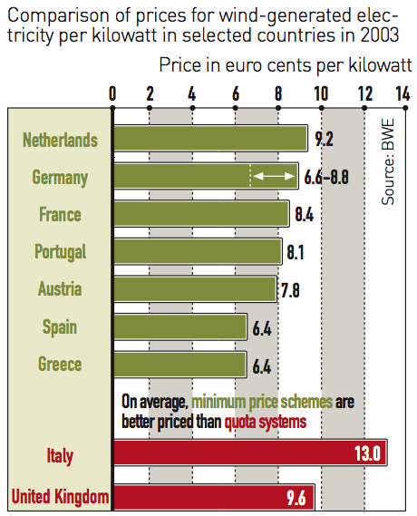
Figure 1. Comparison of prices for wind-generated electricity per kilowatt in feed-in and quota systems in various countries (Grotz, Fouquet, 2005)
Empirically, minimum-price systems have been more successful in advancing the development and use of renewable energy technologies than quota systems (see Figure 2). The attempts to explain the success of the feed-in tariffs underline the fact that feed-in tariffs provide lower investor risk compared to other support schemes (Grotz, Fouquet, 2005).
Apart from the efficiency and effectiveness of support policies, a long-term and stable policy environment is essential for the success of developing renewable energy markets. In other words, the way in which a country applies any given policy has a huge impact on its perceived success. For instance, a stable and supportive policy framework for renewable energy has been put in place in Germany and other European countries alongside the feed-in tariffs schemes; this step has contributed a perceived success of the feed-in mechanism (Bürer, Wüstenhagen, 2009).
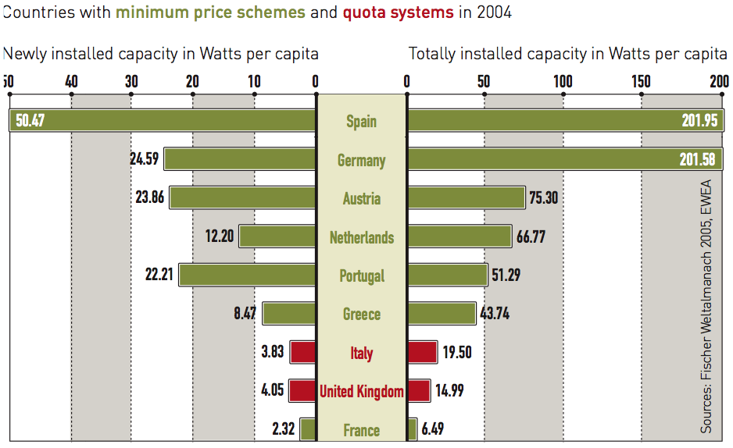
Figure 2: Installed capacities in countries with feed-in and quota systems, 2004. (Grotz, Fouquet, 2005)

3. International Experiences from developing countries

3.1. Successful example: India
India is one of the leading non-industrialised countries in terms of energy and environmental legislation. The following sections respectively outline Indian policy and analyse why it is attractive for investors, how it ensures that India does not incur excessive costs, and what Iran could learn from this example.

3.1.1. India’s renewable energy policy
The first reforms to make the Indian energy sector more favourable to renewable energies were undertaken in 2003 and 2006 with the Electricity Act and the National Tariff Policy (Pew Center, 2008). These laws oblige the Central Electricity Regulatory Commission (CERC) to supply a certain share of total electricity form renewable sources and to buy the required amounts from suppliers (ibid.). This Renewable Purchase Obligation has been set at 5% for the year 2010, and will grow by one percentage point a year (CERC, 2009). CERC is also responsible for setting the feed-in tariffs (Gipe, 2009). The organisation has specified that all renewable feed-in tariffs will be designed in the form of preferential tariffs for the time span of dept repayment that provide for an appropriate internal rate of return on the investments (ibid.). Tariffs are calculated before tax and should grant a normative return on equity of 19% for the first 10 years, and 24% after that (ibid.). Further, the discount rate on which the premiums will be based is the average weighted costs of capital, and the life expectancy of each technology will be taken into account (ibid.). For wind-generated power, the feed-in tariffs also depend on the wind intensity at the respective sites (ibid). Four bands of wind power density have been designed in order to specify the Capacity Factors (ibid.):
- 200-250 W/m²: 20%
- 250-300 W/m²: 23%
- 300-400 W/m²: 27%
- >400 W/m²: 30%
The premiums will be paid for 25 years for PV and CSP projects, for 35 years for small-scale hydropower (< 3 MW) and for 13 years for all other technologies (ibid.). Tariffs will first be reviewed after three years, except for PV (after one year) (ibid.).
Recently, the Indian government has placed particular emphasis on solar power. In 2008, the government introduced the first National Action Plan on Climate Change (NAPCC), which outlined eight national missions in different core areas (Pew Center, 2008). Among them is the Jawaharlal Nehru National Solar Mission, which was devised to run in three phases until 2022. Its aim is to position India as a global leader in the solar energy domain and to set up the necessary political framework (MNRE, 2010). Table 2 displays the target capacities for solar energy.

Application segment | Phase I  (2010-13) | Phase II  (2013-17) | Phase III  (2017-22)
Solar collectors | 7 million m² | 15 million m² | 20 million m²
Off-grid solar | 200 MW | 1,000 MW | 2,000 MW
On-grid solar | 1,000-2,000 MW | 4,000-10,000 MW | 20,000 MW
Table 2. Target capacities for solar energy (MNRE, 2010).
In order to meet these targets, the government introduced a special Renewable Purchase Obligation for power utilities, with a given share for solar electricity that will be increased over time (from 0.25% in phase 1 to 3% in phase 3), while the feed-in tariff for solar power is scheduled to decline (MNRE, 2010). Tariffs have been set at Rs. 18.44 /kWh for PV and at 13.45 /kWh for CSP and are guaranteed for 25 years (Appleyard, 2010). Concerning the legal framework, sector-specific regulations for solar power are to be set up in the long run. In the short run, however, in order to enable a quick launching of the National Solar Mission, existing legislation – notably the Electricity Act 2003 – will be amended as required. Moreover, the mission document suggests the creation of a Renewable Energy Certificate system so that utilities can trade off their renewables surpluses and needs. Fiscal incentives are envisioned for specific capital equipment, critical materials, components and project imports. Further, the government intends to promote domestic manufacturing capacities, R&D and demonstration projects. (MNRE, 2010)
The development of wind energy in India began in the 1990´s, after the announcement of the private power policy and has significantly increased in the last few years. India’s wind power potential has been assessed at 45.000 MW. At first wind farms were installed in the coastal areas of Tamilnadu, Gujarat, Maharasta and Orrisa. Now wind farms have been installed in more then nine states of India. The growth of wind power in India is shown in Figure 3.
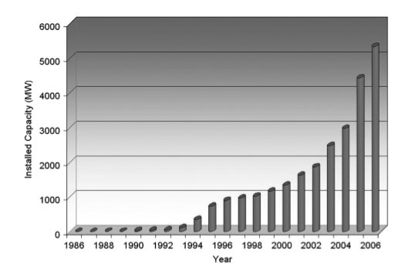
Figure 3 Growth of wind power in India. (M. Carolin Mabel , E. Fernandez)
In 2009 India was raking 5th in the world in installed wind power capacity with a total capacity of 10,925 MW (See Figure 4). India is also one of the leading countries in percentage increase of installation capacity with an average annual increase of 35.4% for the past 5 years.
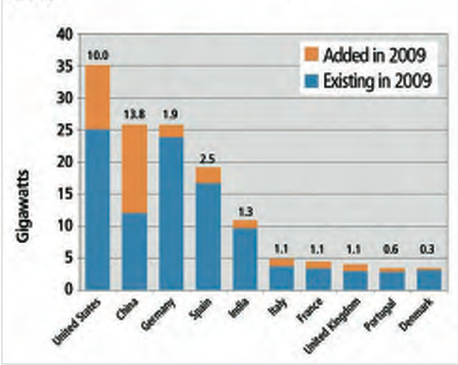
Figure 4 Current position of the Indian wind energy sector (Renewable Energy Policy Network for the 21st Century, Global Status Report)
While India had to depend on imported turbines in the 1990´s, the local manufacturing capacity has improved remarkably in the last 15 years. Suzlon Energy is an Indian owned wind turbine manufacturer. It is the best example for the development of the wind energy industry in India. Suzlon Energy is one of the leading wind turbine producers with manufacturing sites in India as well as in China, Germany and Belgium. In terms of market share, Suzlon is the largest wind turbine manufacturer in Asia and the 5th in the world.

3.1.2. How does India ensure that this is attractive for investors?
The criterion of success for any feed-in tariff system is whether or not investors consider it profitable. Hence, it is crucial to understand how one can assess whether a renewable support scheme fulfils this condition.
The journal Energy Policy published a case study conducted by Purohit and Purohit (2010), in which they evaluate if investments in CSP generation plants would be financially attractive in India. Using solar radiation data provided by the Indian Meteorological Department for fifty representative sites in India, they evaluated the financial feasibility for two types of CSP plants modelled on two existing generation units in Spain – the 50 MW parabolic trough plant ANDASOL-1 and the 11 MW power tower PS-10. Their calculations show that similar plants would cause electricity costs ranging between Rs. 9.23 and 28.42 1/kWh for ANDASOL-1 and between Rs. 8.75 and 27.04 1/kWh for PS-10 at the selected fifty different sites. Assuming a feed-in tariff between Rs. 10 and 13 per kWh, they are able to locate where in India investment in CSP would be profitable. Expected cost reductions between 20 and 30% for parabolic trough systems, and between 15 and 30% for power towers by 2020 would make some more locations eligible for investment. The same effect is achieved by accounting for possible CDM benefits. Calculating with a baseline of 800 to 850 g of CO₂ emissions per kWh, and a CER (Certified Emission Reduction) price of 15 Euro, electricity costs are reduced to Rs. 8.56-27.64 /kWh for the ANDASOL-1 model, and to Rs. 7.97-26.26 /kWh for PS-10. Hence, there is substantial potential for financially attractive investment in CSP in India, especially considering that with Rs. 13.45 /kWh, current feed-in tariffs for CSP are higher than assumed in the case study.

3.1.3. How does India ensure that it does not incur excessive costs?
Yet, it is not enough for the remuneration scheme to be attractive for investors; it also has to be financially feasible for the state budget.
The Indian tariff system is based on some general considerations of the Ministry for New and Renewable Energies. The aim of the Solar Mission is to cause costs for solar technologies to decline due to economies of scale. Current electricity prices for coal generation, which accounts for more than half the electricity produced in India, are close to Rs. 7 /kWh for base load, and Rs. 8.50 for peak load, with costs for diesel-generated electricity used in times of shortages at Rs. 15. Costs for coal-generated electricity are expected to rise as India starts importing coal, and the ministry assumes cost parity with solar-generated electricity to occur in 2022. These considerations show that the government expects to be able to provide investors with profitable tariffs without imposing an additional burden on its economy.
According to the Ministry for New and Renewable Energies, the National Solar Mission has been designed to take into account financial constraints. Funding is to be provided by two sources, the national budget and international funds under the UNFCCC framework. The government is already working on a scheme intended to enable quick investments while limiting costs for the government. The national mission schedules five evaluations of the Solar Mission until 2022, notably to protect the government from having to subsidise its solar plan. Thus, concrete financing needs for phase two of the plan are, for instance, to be devised in 2012. Feed-in tariffs for solar power are to be reviewed annually, accounting for current costs and technology trends. Further, one possibility to soothe financing pressures for the utilities, which are obliged to purchase renewable electricity, is to bundle solar power with unallocated electricity from less expensive plants and to sell this mix to utilities at the standard price set by the regulating agency. (MNRE, 2010)
In sum, close market monitoring, regular evaluations and quick adjustments of the tariff- policy can ensure that the financial burden of a remuneration scheme does not exceed a country’s capacity.

3.1.4. What can Iran learn from this example?
The Indian feed-in tariff system provides security for investors because it guarantees a fixed price per kWh and obliges retailers to buy solar-generated electricity. Especially convenient for investors is that the Indian price calculations are based on the real cost of investments and include a profit margin. The differentiation according to technologies, and even according to wind intensity testifies to the thoroughness with which the scheme has been elaborated. Regular revision of tariffs ensures their appropriateness and safeguards the state from excessive expenditure.
The techno-economic assessment of Purohit and Purohit (2010) shows how a country can determine financially attractive yet feasible feed-in tariffs. The rigorous methodology and investor-based approach of the case study lend themselves to similar calculations for different locations in Iran. In this context, it is important to have reliable, detailed potential data covering all climatic regions of the country, and to know specific investment costs like the discount rate. Thus, it could be possible to design feed-in tariffs that are adjusted to local conditions in the different countries.

3.2. Unsuccessful Example - Algeria
An example of a country from the broader Middle Eastern region that has introduced a feed-in tariff for electricity generated from renewable sources is Algeria. The following sections respectively describe and assess the Algerian legislative framework based on the project results of Wuppertal Institute, Adelphi Consult (2009) and Wuppertal Institute, CREAD, (2010).

3.2.1. Description of the Algerian incentive scheme for renewable energies
In Algeria, legislation in favour of renewable energies started in 2002, with the Law on electricity and on gas distribution via pipelines (Law n°02-01). This law prepared the grounds for comprehensive liberalisation reforms of the Algerian electricity sector and laid out a national programme for the promotion of renewable energies. Thus, among other innovations, the law stipulates that anyone is allowed to construct power generation units. However, the newly established regulatory commission CREG (Commission de regulation de l’électricité et du gaz) needs to approve any new installation that feeds electricity into the national grid and exceeds a capacity of 25 MW. Similarly, CREG is responsible for granting concessions for the transmission of electricity via the national grid, which remains a monopoly even under the new law. The law further envisages the creation of a system operator for electricity distribution and of a market regulator for the electricity market, but these have yet to be introduced.
Further progress in the promotion of renewable energies was made in 2004, with decree n°04-92 that set up the first precisely defined feed-in tariff system for renewable electricity in Africa. The scheme details the size of the premium to be paid for each type of renewable energy in addition to the standard market price. It includes special rates for hybrid plants (gas and solar), with the premium depending on the share of solar in total electricity generation.
The provided bonuses are:
Wind electricity 300 %
Solar electricity (PV or CSP) 300 %
CSP with gas co-firing:
Solar contribution of 20-25 % 180 %
Solar contribution of 15-20 % 160 %
Solar contribution of 10-15 % 140 %
Solar contribution of 5-10 % 100 %
Solar contribution of 0-5 % 0 %
Hydroelectricity 100 %
Cogeneration plants 160 %
Waste incineration plants 200 %
Electricity prices are heavily subsidised in Algeria; hence, the devised remuneration scheme is not profitable for investors. On a case-to-case basis, some investors have negotiated special remuneration tariffs for individual investment projects. This has allowed for the realisation of some renewable energy ventures, the biggest one being a hybrid plant (solar energy supplementing a gas-fired combined cycle process) at Hassi R’mel, which was constructed by the NEAL consortium, a semi-public joint venture.
2004 saw some further development in the domain of renewable energies legislation, with the Law on the promotion of renewable energies in the context of sustainable development (Law n°04-09). This law introduced the National Programme for the Promotion of Renewable Energy, with elements like public sensitisation campaigns and regular assessments of the beneficial effects of renewable energies. It also stipulated the introduction of a renewable certificate system, and the creation of a monitoring body (the Observatoire national de promotion des energies renouvelables), which have not yet been achieved.

3.2.2. Evaluation of the Algerian incentive scheme for renewable energies
In Algeria, one notices a disparity between the success of public renewable energy programmes and the creation of incentives for private investment. While programmes for the installation of solar water heaters in households and for rural and desert electrification have yielded considerable successes, the above-mentioned frameworks, intended to incentivise private ventures, have proven flawed.
Shortcoming of the laws and decrees are:
- New power plants for feed-in into the national grid that are bigger than 25 MW need to be approved by CREG.
- Electricity producers are entitled to sell either their whole production or only surpluses to the national utility Sonelgaz. Due to its monopolistic position, Sonelgaz is advantaged in negotiations.
- The subsidised electricity base price is so low that the premiums paid for renewable energies are ineffective. A realistic profitable fixed tariff (per kWh) would grant more security than the premium scheme.
- The system operator for electricity distribution and the market regulator for the electricity market envisaged by the 2002 law as well as the National Observatory for the Promotion of Renewable Energies and the certificate system stipulated by the 2004 law have not yet been introduced. This means that the legal framework of the electricity market is not complete.
Overall, the current Algerian framework for renewable energies lacks financial and legal security for investors.

3.2.3. What can other developing countries learn from this example?
It is of utmost importance to create financial incentives and legal security for investors. Therefore, firstly, feed-in tariffs have to be high enough to make investments attractive. Hence, actual investment and generation costs need to be considered when fixing the premiums or the feed-in tariffs. Specifying a time span for which the remuneration scheme is guaranteed creates additional security. Secondly, the purchase obligation for established electricity providers needs to be very clear and valid for the whole amount of renewable energies produced. This includes the duty to provide sufficient grid capacity for the integration of additional electricity from renewable sources.

4. Iranian Development and Situation

4.1. Rationales for Renewable Energy Investment in Iran
Investment in renewable energies in an energy-rich country may not sound like an optimal economic decision, as the country can capitalize on its vast conventional energy resources to develop the economy. In addition, the renewable energy technologies are still in their infancy stage, and therefore in some cases expensive and unaffordable in developing countries. Notwithstanding the facts above, developing countries including energy rich countries will likely benefit from investing in the renewable technologies. The rationales for investing renewable energy programs can be summarized as follows.
- Demand for energy in Iran as a developing country is rapidly rising. The energy scenario study by IEA-WI (2009) shows that under the BAU scenario, the total demand for energy in Iran will almost double by 2030. The increasing trend of domestic demand for fossil fuel will lead to an exhaustion of conventional energy sources, particularly oil, in a couple of decades, turning Iran from an oil exporting to an oil importing country. Therefore, although energy security may not be an urgent problem for Iran, it will be soon.
- There is a long-term economic benefit in investing in the renewable energy projects in Iran. Table 3 compares the input costs of conventional power plants versus the renewable energy power plants. The main benefit arises from the fact that free inputs such as solar radiation or wind will substitute oil and natural gas, whose world market prices are positive and rising. Power plants using renewable energies, in comparison with those using conventional oil or natural gas, will require higher capital costs, but are less labour intensive. The cost of capital will also decline as the technology is rapidly improving. Therefore, in total, it pays to construct new renewable energy based power plants and use the savings for investment in R&D for renewable energy technologies.

Power Plant Type | Inputs
 | Fuel | Capital | Labour | Technology
conventional | + |  | +
Renewable energy |  | + |  | +
“+” sign shows relatively higher intensity.
Table 3: Cost Structure in Conventional Power Plants versus Renewable Energy Power Plants

- The application of renewable energy will decrease emissions significantly. This is particularly important for Iran as the country is rapidly approaching industrialization stage with increasing demand for energy and rising water and air pollution. As IEA-WI (2009) shows the level of CO₂ emission and other pollutants in BAU scenario will double in Iran by 2030, but it will reduce by 45 percent under the combined efficiency and renewable energy scenarios. Reducing emission will decrease direct costs on measures to reduce pollution and to protect environment as well as indirect external costs such health care costs.
4. Renewable energy technologies are diverse but growing fast. The scientific research is at forefront of research agenda in universities and research institutes across the developed nations. The outcome of these researches will help bring down the cost of capital and equipment and increase efficiency, particularly in wind and solar energies technologies. Some developing countries such as China and Iran have already started producing some parts of the wind energy equipment, like blades and gear boxes, but producing more efficient parts and more importantly engines or solar cells are critical and requires high skilled labour. Investing in renewable energies will encourage an investment in human capital and in learning know-how. This is particularly important for Iran as the country has a relatively young population structure with high demand for higher education and a large supply of labour.

4.2. Renewable Energy Development Objectives
Iran intends to access the technologies pertaining the production and use of renewable energy resources in order to align itself with sustainable development objectives. New studies reveal that with the development of renewable energy resources, the country would be able to generate as much as 2,000 MW electricity by the end of the Fifth Four Year Development Plan (2010-2015). According to the objectives set forth in the 20-Year Outlook, Iran should become a regional power in terms of production and use of renewable energy resources by 2025. The objectives envisaged in the plan are as follows:
- Electricity generated from renewable energy sources should account for 10 percent of the total electricity generated in the country
- Security of the country’s energy network should be assured through diversifying energy resources in the energy basket
- The environmental conservation should be promoted through reducing ecological pollution
- Policy-making strategies in renewable energy resources should be improved
- The country’s capabilities in the field of renewable energy resources should be optimized
- More financial supports should be provided for research, development and creating technical knowledge in order to improve competency of renewable energy sources with other sources of energy

4.3. Renewable Energy Potentials
The share of renewable energy in producing electricity is currently about 3 percent, but has a potential to increase to 38 percent in 2030. The share can even go higher to 57 percent if energy is used more efficiently in all sectors which will reduce demand for electricity (IEA-WA, 2009).
According to Renewable Energy Headquarters’ report, the following targets for using renewable energy sources in Iran are proposed.
- Wind: 6500 MW
- Hydro: 90 MW in 15 years
- Solar and PV: 5 MW in independent power generating plants and 30 MW in power generating plants connected to network
- 10,000 solar water heaters are produced and installed
- One power generating plant with 100 MW capacity
- More than 2 MW PV electricity is generated
- Biomass: 137 mbo
- Geothermal: 200 MW in 10 years
The Iranian Energy Association and the Wuppertal Institute for Climate, Environment, and Energy have recently studied the potentials for renewable energy development in Iran using a scenario analysis. It is assumed that the nuclear plants will generate the base load with 1000 MW capacity in 2009 and the thermal plants along with renewable sources will generate the rest. Based on the Ministry of Energy plan, the new thermal plants will be combined cycle and the main renewable sources hydro and wind power plants. Installed hydro capacity will be more than 7000 MW capacity in 2011 and 8500 MW by 2030. Wind power capacity will increase from 37 MW in 2005 to 1187 MW in 2030. Small hydro, solar thermal, geothermal, and biomass plants will generate 720 MW, 1 MW, 55 MW, and 5 MW, respectively. A pump storage plant in Siah Bisheh will be installed in 2010 with a power of 1000 MW. A summary of the business as usual (BAU) and High-Renewable scenarios for the renewable energy development is presented in Table 4. Overall, given the total electricity generation in 2030, the share of renewable sources in producing electricity will rise from about 3 percent under the BAU scenario to 38 percent under the High-Renewable scenario. The main source of renewable energy growth will be solar followed by geothermal and wind power. The details of developments in each type of renewable energy sources are as follows.
 |  | 2005 | 2030
 |  |  | BAU | High Renewable
Total Electricity Generation (million kWh) |  | 186,537 | 346,375 | 346,375
Renewable Sources |  | 4,720 | 10,111
 | Hydro power | 4,500 | 7,030 | 17300
 | Wind power | 220 | 2,730 | 22000
 | Photovoltaic | 0 | 7 | 7
 | Geothermal | 0 | 303 | 5250
 | Solar thermal power | 0 | 4 | 94000
 | Biomass | 0 | 18 | 18
 | Total | 4,720 | 10,111 | 138,575
 | RE/Total Electricity Generation (%) | 3 | 3 | 38
Source: Tavanir and authors’ estimation, Energy Scenarios Study in Iran, IEA and WI (2009)
Table 4: Electricity Generation by Renewable and Non Renewable Sources (GWh)- BAU Scenario (2005-2030)

4.3.1. Wind power
There exist very different estimates of wind power potential in Iran; estimates from the World Bank start at 6500 MW, whereas SUNA places potential between 12000-16000 MW (CEERS et al. 2006). Assuming 2000 full load hours, the latter estimate leads to a potential generation of 32 TWh/a electricity. The forthcoming wind atlas provides more detailed data. Given the wide range of wind power potential estimates in different studies, we take the estimate closer to the international studies including the study by a German company in Khusistan (Hagenkort, 2004, Kipke, 2004), and assume that wind power has a potential to generate 22 TWh/a electricity by 2030.
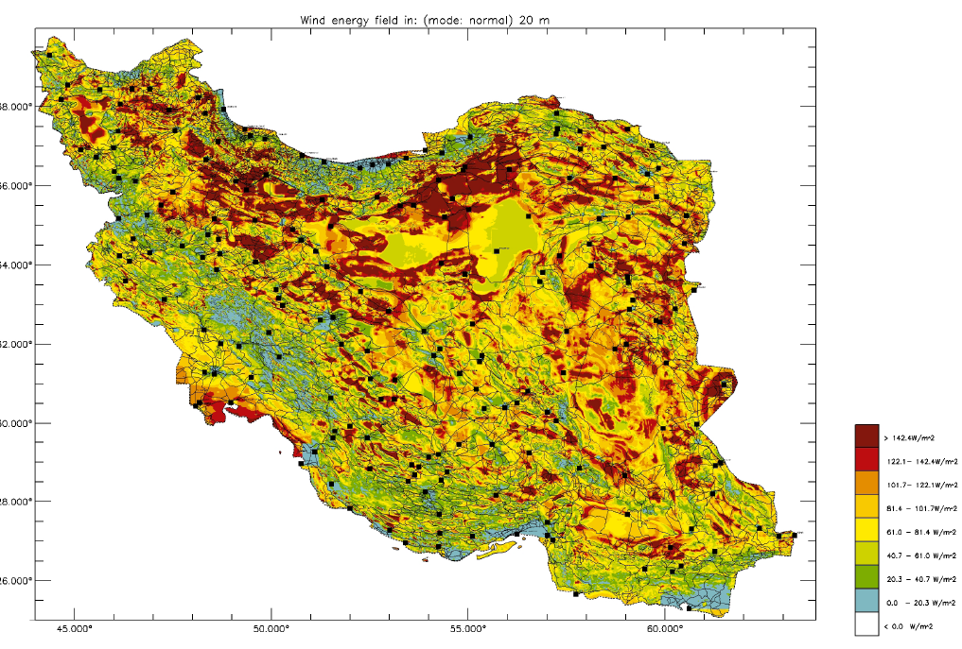
Figure 4: Iran Renewable Energy Organization (SUNA)
The first industrial application of wind power in Iran occurred in 1995. Two wind turbines with the capacity of 500 kW were purchased and installed in the province Gilan (North of Iran). Currently Iran has five wind farms with a total capacity of 128 MW. The wind farms are located in two provinces: Gilan (North) and Khorasan (Northeast).
Wind farms in province Gilan:
The province Gilan is located in the North of Iran and South of the Caspian see. There are two areas certified for having a potential for wind power use: Manjil and Rudbar. Those areas are located in the so called ‘’Manjil wind channel’’ with an average annual wind speed of 7 to 11 m/sec. In Manjil a wind farm is installed with a total capacity of 101.68 MW.
Wind farms in province Khorasan:
This province is located in the North-East of Iran. The potential area for using wind power is at the mountain range of Binalood near the city Naishabur. In this area a wind farm is in operation with a total capacity of 28 MW.
Production and construction of wind turbines:
The first wind farms in Iran have been erected in cooperation with foreign companies. Thereby Iran has gained the knowledge to design wind farms, including site selection, layout of the turbines, mechanical and electrical design and installation of wind turbines independently.

After the first imports of wind turbines from foreign companies, the Iranian government decided to invest in production of wind turbines in Iran. As a result Saba Niroo was established as the first and only manufacturer of wind turbines in Iran and in the Middle East in 2000. Saba Niroo presents its products under the license and supervision of Vestas Wind System. The Iranian manufacturer produces turbines with a capacity of 300-660 kW.
After the introduction of the Iranian feed-in tariff system, private investments become more attractive in wind energy sector. 20 wind farms of private investors have already received licences with a total capacity of 712 MW. These investors are facing problems to purchase wind turbines with higher capacity. At this time Saba Niroo is not able to provide turbines with a capacity of more than 660 kW (Rasuli Hamed, 2010).

4.3.2. Biomass
The DLR (2005) lists a biomass potential of 24 TWh/a electricity, but this figure includes municipal waste. There are different estimations regarding the biomass energy sources in Iran and without a rigours study it is hard to rely on them. IEA-WI (2009) estimates 0.018 TWh/a electricity generation by biomass in 2030.

4.3.3. Geothermal
Geothermal primary energy sources are relatively well investigated in Iran, but there is still a lack of knowledge on economic and technical potentials. Talebi (2004) from SANA estimates the country-wide geothermal electricity potential to be in the range of 5000 MW to 6000 MW_{el}. As geothermal energy can be used for base load electricity on a 24/7 basis, full load hours (FLH) are high. Assuming 7500 FLH, about 37 – 45 TWh electricity could be produced per year. However, since geothermal hot spots are far from inhabited areas, heat cannot be used. Therefore only the electrical option remains for geothermal energy utilisation.
In total, there are 14 promising regions for geothermal development in Iran, which can be divided into three categories (Talebi 2004, Fotouhi 1994):
Category 1- Sabalan/Meshkin-Shahr: This area has been explored in detail; geothermal potential has been investigated in-depth and temperatures are well known. Iran’s first geothermal power plant is being built in this area.
Category 2- Khoy-Maku, Sahand, Damavand: These regions were identified as potential geothermal sites in the 1970s. They have been explored relatively well and the details of their energy contents have already been estimated.
Category 3- Takab, Ramsar, Isfahan, Khur, Ferdows, Nayband, Bushehr, Lar, Bandar Abbas, Taftan-Bazman: These areas have been identified as potential geothermal regions, but detailed assessments have not yet taken place.

The data sources in Table 5 give details on the energy contents of Iran’s geothermal regions.
Location | Energy Potential | Note
Sabalan* | 32*10¹⁸ J - 48*10¹⁸ J
Meshkin-Shahr project | 250 MWe | Project budget: $US 250 million
Khoy-Maku** | 30*10¹⁸ – 40*10¹⁸ J | Surface temperatures between 25 and 63 °C
*Fotouhi 1995, 1994, Fotouhi/Noorollahi 2000
**Noorollahi 2004
Table 5: Geothermal Potentials in Iran

It is expected that by 2030, geothermal sources will be able to produce 5.25 TWh/a electricity. The utilised potential will remain far behind the maximum potential, due to the relative short timeframe to 2030.

4.3.4. Solar irradiation
Solar irradiation is very high in Iran and the sunny hours that could be utilized are about 2800 hours per year (Atabi, 2004). DLR (2005) assesses a direct normal irradiance of 2200 kWh/m²/a. This study estimated the total economic potential for the use of concentrating solar power plant (CSP) via satellite imaging. It analyzed the relevant topographic aspects of different areas in the country including water surfaces, and high inclinations. One can also estimate the total area that could be used for the erection of other solar power solutions such as photovoltaic power. In general, utilisable surfaces in Iran are so large that they will not be a limiting factor for solar energy utilisation.
Samimi (1994)’s country-wide analysis of irradiation concluded that on 80 percent of Iran’s territory solar irradiation would be between 1640 and 1970 kWh/m²/a. The highest values are reached in the central-Iranian region. Geyer (1997) provided detailed measurements of solar intensities in selected sites. He presented a maximum direct normal insolation in Shiraz of about 2580 kWh/m²/a. Data for Yazd are of particular interest, as tender documents for a solar thermal power plant in the area were prepared. According to IPDC (2001) solar insolation in Yazd is in the range of 2500 kWh/m²/a. In the scenario analysis by IEA-WI (2009), based on the assumptions on the capacity installation rate and the full load hours, it is estimated that 94 TWh/a electricity will be produced by CSP and 0.007 TWh/a by photovoltaic generation.

4.3.5. Hydropower
Hydropower produces less than 10 TWh/a electricity and therefore its contribution to energy production is not significant in Iran. However, there are plans to increase hydropower’s share in the electricity mix. The World Energy Council (WEC) and DLR estimate Iran’s hydropower potential to be 48 TWh/a (DLR 2005, WEC 2001), and the IEA-WI (2009) estimates that large hydropower will contribute to electricity generation by producing 17.3 TWh/a.
Table 6 summarizes the renewable electricity performance indicators estimated by DLR (2005). They define the representative average renewable electricity yield of a typical facility in Iran. Table 7 shows the economical renewable electricity supply side potentials for Iran (DLR, 2005).

Energy sources | Measure | Basic data on energy potential | Remarks
Hydro | Full Load Hours per year (h/y) | 1351 | Well documented resource taken from literature
Geo | Temperature at 5000m Depth (Celsius) | 295 | From 5000m temperature map considering areas with T>180 C as economic
Bio | Full Load Hours Per Year (h/y) | 3500 | Agricultural (bagasse) and municipal waste and renewable solid biomass
CSP | Direct Normal Irradiance (kWh/m2/y) | 2200 | From DNI and CSP site mapping taking sites with DNI>2000 kWh/m2/y as economic
Wind | Full Load Hours Per Year (h/y) | 1176 | From wind speed and site mapping taking sites with a yield>14 GWh/y and from literature (EU)
PV | Global Horizontal Irradiance (kWh/m2/y) | 2010
 | Full Load Hours Per Year (h/y) | 4000
Table 6: Basic data on renewable energy potentials in Iran; Source: DLR (2005)

 | Hydro | Geo | Bio | CSP | Wind | PV
Electricity Supply | 48 | 11.3 | 23.7 | 20.000 | 8 | 16
Table 7: Summary of Economic Renewable Electricity Supply Potentials in Iran, TWh/y Source: DLR (2005)

4.4. Renewable Energy Organizations
There are a number different organizations dealing with renewable energy development in Iran. Recently, the Iranian Deputy President for Scientific and Technology Affairs set up the ‘Headquarters for Development of Renewable Energies’ to coordinate all activities concerning renewable energies. Public organizations and ministries involved with the Iranian renewable energy sector include:
- Oil Industry Research Academy; Ministry of Oil
- Renewable Energy Organization of Iran (SANA); Ministry of Energy
- Science and Industry Research Institute; Ministry of Science, Research, and Technology
- Environmental Protection Organization, Vice President
- Iranian Fuel Conservation Organization – IFCO; Ministry of Oil
The Oil Industry Research Academy has been chosen as the secretariat for the headquarter committee and the following seven sub-committees have also been established:
- Planning and policy making
- Hydro
- Wind and wave energy
- Hydrogen
- Solar energy
- Biomass
- Geothermal
The Oil Industry Research Academy, which was established in 1960, conducts research on oil and its derivatives, but has recently engaged in areas such as fuel quality, alternative fuels and additives, energy consumption optimization, waste and pollution reduction. The academy’s main research area is now renewable energies, particularly hydrogen.
The Renewable Energy Organization of Iran (SUNA) was set up in 1995 aiming to develop applications of the energy generated from renewable energy resources. SANA’s main objectives are stabilization and diversification of energy resources by extending existing capacities and reducing the long-term costs of energy generation and protecting the environment. In order to achieve its mission, SUNA implements the following principles:
- Active participation in drawing up the ‘National Energy Plan’ and other strategies concerning renewable energy sources in the country
- Active participation in creation and management of guaranteed markets for the producers of renewable energy sources
- Conducting feasibility studies for various types of renewable energy sources
- Creating communication between Iranian and international experts and organizations active in the fields of renewable energy sources
- Identifying, attracting and channelling international sources in Iran’s renewable energy sector
- Drawing up new strategies to develop technologies relating to renewable energy sources and supporting research centres active in the related fields
- Monitoring the latest developments in the field of renewable energy sources and communicating these findings with the research centres
- Preparing the groundwork for transferring, attracting and exporting the related technologies
- Setting up criteria and rules for protecting production and R&D activities related to renewable energy sources
- Encouraging the nation to use renewable energy sources
The Science and Industry Research Institute which is affiliated with the Ministry of Science, Research, and Technology, has been working on renewable energy sources since 2004. The Institute’s main research focus has been on solar energy.
The Iranian Fuel Conservation Organization (IFCO), which was established in 2000, has been developing standards for energy use in industry, transportation, and household sectors. It also provides technical and financial support to projects that lead to a higher level of efficiency in energy use. The organization has also supported projects dealing with energy generation from renewable sources. Some recent activities by the organization are as follows:
- Production and installation of 15°000 residential solar water heaters
- Production and installation of 1°000 public solar water heaters (rural solar baths)
- Feasibility studies for production of bio ethanol
- Feasibility studies for bio diesel fuel
- Study on wind energy
The Ministry of Energy has also carried out the following activities concerning renewable energy sources:
- Assessing the country’s status on renewable energy resources in 2007, or the Iranian year of 1387;
- Laying out a roadmap for the renewable energy resources in Iran
- Strengthening the international cooperation in the field of renewable energy resources

4.5. Renewable Energy Development Act
In 2001, the Iranian parliament passed an important law to support private sector investment in renewable energy sources. Under Article 62 of the “Law of Government’s Financial Regulation” passed on 19 February 2001, the Ministry of Energy is obliged to purchase electricity produced by public and private power plants at guaranteed prices. The feed-in rates required by the law were 650 Rials (US $0.067) per kWh for peak and regular times, and 450 Rials (US $0.047) for off-peak times (maximum four hours per day). SANA was identified as the organization responsible to sign contracts with investors, provide services and monitor the development of the renewable energy industry.
On February 24th 2005, the Ministry of Energy was provided instructions on how to implement Article 62 (See appendix 1 for details), and on November 23rd 2008, the government adjusted the feed-in rates to reflect increasing investment costs due to including inflation. The rates increased from 650 Rials (US $0.067) per kWh to 1,300 Rials (US $0.13) per kWh during peak consumption periods and from 450 Rials (US $0.047) to 900 Rials (US $0.094) during off-peak periods. The new rates were implemented from March 2008- March 2009 (or the Iranian year of 1387), and were subject to revisions in the following years.
The rate revision is based on inflation and the changes in exchange rate (rial to US-dollar). The formula assigns weights to inflation and exchange rate changes, but allows investors to choose their own weights. The rate revision formula also discounts the adjustment factor by 2 percent each year to encourage innovation and technological advancement to reduce costs. Specifically, the rate adjustment is based on the following formula:
i=(P_{n/}P_{o})^{α}(E_{n/}E_{o})^{1-α} /1.02t
where ‘i’ is the rate adjustment, ‘P’ is the consumer price index, ‘E’ is the exchange rate, ‘n’ and ‘o’ are the number of periods, and ‘t’ is time. ‘α’ and ‘(1-α)’ are the weights assigned to the respective changes in prices and exchange rates.

4.6. Power Generating Plant Applications
Wind and solar are f the most important and viable renewable energy sources in Iran. It has been estimated that in 26 areas of the country, as much as 6500 MW electricity can be generated by wind (assuming an efficiency of 33%). Therefore, wind energy projects in Iran are well ahead of all other alternative renewable energy sources. Up until 2009, a total of 20 private sector wind plants had been approved and were underway, which represents a combined capacity of 712 MW. From this, 8 plants with a total capacity of 439 MW have signed a feed-in contract with SUNA. Furthermore, there are applications for 21 additional wind power plants that are in the feasibility study phase, which represents a capacity of more than 1000 MW. Solar irradiation is very high in Iran. DLR (2005) assesses a direct normal irradiance of 2200 kWh/m2/a and Samimi (1994) in his country-wide analysis of irradiation concludes that on 80 percent of Iran’s territory solar irradiation would be between 1640 and 1970 kWh/m2/a. The highest values are reached in the central-Iranian region. There have been some applications to develop solar energy in Iran, but given the vast resources the potentials, this area is still highly unexplored. The most important applications are for plants in central Iran, Shiraz and Yazd, where the tender documents for a solar thermal power plant are being prepared. According to IPDC (2001) solar insolation in Yazd is in the range of 2500 kWh/m2/a.
Another important renewable energy resource in Iran is biomass. So far, four projects with a total capacity of 26.1 MW have been approved and are underway. From this, three plants with the capacity of 13.6 MW have signed guaranteed purchasing contracts with SANA. In addition, there are feasibility studies for 3 more plants with a total capacity of 50 MW.
There are also several applications for small hydro plants in different areas of the country. So far, there have been seven applications for small hydro projects, which represent a capacity of 30 MW.

5. SWOT analysis of the Renewable Energy Organisation in Iran
An analysis of strength, weakness, opportunities, and threats (SWOT) for the Renewable Energy Organization (REO) in Iran was done by Moradzadeh (2009). In the following, a summary of the research findings is presented. The results are based on two questionnaires completed by a sample of 155 experts in energy and renewable energy areas. The first questionnaire asks 30 questions about the strength, weakness, opportunities, and threats, and the second questionnaire asks experts to assign weights to SWOT cases and to rank the factors listed in the first questionnaire. The score results are summarized in two matrices: Internal Factor Evaluation (IFE), and External Factor Evaluation (EFE).
A list of SWOT of the REO is presented as follows:
Strengths  1. Skilled labour  2. Equipment and facilities  3. Maintenance ability  4. Marketing  5. Capacity in installation, construction, and operation of renewable energy systems  6. High interest and expertise among the managers of the renewable energy organization | Opportunities  1. Educational programs to disseminate knowledge about the renewable energy in Iran  2. Private sector involvement in renewable energy in Iran  3. International cooperation and participation in renewable energy investments in Iran  4. Iran’s favourite geographical position in terms of renewable energy sources  5. World Bank’s grants for renewable energy projects  6. Tax on fossil fuels  7. Security of renewable energy system
Weaknesses  1. High investment costs of the renewable energies in Iran  2. Lack of R&D  3. Lack of financial resources  4. Low ability of raising capital  5. High cost of grid connection  6. Low level of human capital in the REO  7. Lack of scientific system and procedures for decision making process in the REO  8. Lack of innovation  9. High price of renewable energies in Iran | Threats  1. Lack of subsidies to renewable energies  2. Technology transfer problems  3. Old technologies  4. Lack of strategic planning for renewable energy program in Iran  5. Lack of law for renewable energy planning  6. Lack of government fiscal policies to support renewable energy programs  7. Lack of consensus among policy makers  8. Lack of acceptance for renewable energy by consumers
A score is assigned to each factor within the IFE and the EFE matrices and a final score is calculated given appropriate weights. The final score ranges from 1 to 5. The score is equal or less than 3 means weak performance of the organization, and a score greater than 3 means satisfactory performance.
The final score in IFE matrix is 3, which shows that the Renewable Energy Organization is a weak organization internally. The final score in EFE matrix is greater than 3, which indicates that the organization is facing with favourite external conditions and opportunities.
Using the SWOT matrix, four strategies for renewable energy development including strengths-opportunities (SO), strengths- threats (ST), weaknesses-opportunities (WO), and weaknesses-threats (WT) are obtained. The list of strategies is as follows.
ST Strategies:
ST1: Planning to use local technology
ST2: Comprehensive planning and management
ST3: Human capital management
ST4: Activities to change fiscal policies
ST5: Public education and awareness about RE
ST6: Marketing for RE
WT Strategies:
WT1: Fiscal planning and financial management for renewable energy programs
WT2: Planning for technology transfer and technology localization
WT3: Fiscal and monetary policies for renewable energy development
WT4: Investment in human capital for renewable energy development
WT5: Preparing a strategic plan for renewable energy development in Iran
SO Strategies:
SO1: Education and training programs in the renewable energy organization
SO2: Coordination, merger, or cooperation among different renewable energy organizations
SO3: Use of international quality control programs such as EFQM in the Renewable Energy Organization
SO4: Application for the World Bank’s grants for the RE
SO5: Training for maintenance of renewable energy equipment
SO6: Management of the existing human capital
WO strategies:
WO1: Developing private-public participation projects in RE
WO2: Lowering project costs
WO3: Investing in R&D
WO4: Management and investment in human resources of the REO.
WO5: Joint RE research projects with other domestic and international organizations
WO6: Financial management of the REO
WO7: Encouraging innovation in RE projects with the cooperation of international organizations
WO8: Appling for international loans for RE investments in Iran
WO9: Education programs to encourage innovation
WO10: Use of scientific and systematic decision making process in REO

6. Renewable Energy Challenges in Iran
Although there is a legal framework and some financial support for the development of renewable energy in Iran, progress is rather slow. By enacting the feed-in-tariff law, the Iranian parliament has demonstrated that developing renewable energy sources is important to Iranian policy makers. However, although this legislation is similar to renewable energy development laws enacted in more than 60 other countries (gtz- TERNA, 2009), it has not been very effective. It is evident that laws by themselves cannot be effective if the environment for their implementing is not supportive and law enforcement is not strong. With this being said, the main challenges facing renewable energy development in Iran can be identified as follows.
- One of the main barriers for the development of the renewable energy sources in the world and Iran is the low price of conventional energies relative to the renewable energies. In Iran, this factor is more pronounced as the country is rich in conventional resources and the energy pricing system has kept the energy prices very low. Any investment in alternative energy sources with the current energy pricing system in effect is uneconomical and not welcome by domestic and foreign investors.
There are huge subsidies for electricity production and consumption in Iran. On production side, fuel costs are kept low by government subsidies on oil and natural gas for power plants. On consumption side, the electricity price is heavily subsidized for both business and households. The low input price along with a high transmission and distribution loss (17%) contributed to low efficiency rates in power plants, which makes the actual electricity price (and therefore the subsidy) much higher than international standards.
- As the SWOT analysis shows, there is no consensus among authorities and policy makers about the importance of investment in renewable energy sources, and therefore a rigorous plan for renewable energy is lacking. Opponents argue that since Iran has abundant fossil energy resources, investment in renewable energy is not a priority. They also argue that since renewable energy technology is still immature, it will be more beneficial to wait until the technology reaches a state where it is able to compete with conventional energy resources.
- Transaction costs, red tape, and uncertainly with regard to policy change and implementation increase risk premiums for investment in renewable energy projects, which diminishes the incentives provided by Iran’s feed-in law.. Unfortunately, developing countries, including Iran, do not have a good record in governance indexes published by World Bank. The 2008 Governance Report shows that Iran is at the bottom of the list ranking 25 among 215 countries in various indexes such as Government Effectiveness, Rule of Law, Corruption Control, Regulatory Quality, and Voice and Accountability (Kaufmann et al., 2009)
- The feed-in-tariff law is a positive step towards attracting private sector investment in renewable energy. However, it has many shortcomings. For instance, the guaranteed feed-in price for electricity is subject to government approval and therefore increases investment uncertainty. Furthermore, law enforcement mechanisms and penalties for violating law by government agencies are lacking, making the law less effective.
- Sanctions by the UN and the unilateral sanctions by the US have affected international trade and financial transactions with Iran, which has made technology transfer and financing renewable energy projects more difficult and expensive. The sanctions have also limited foreign investment in different sectors including renewable energy (see the SWOT analysis).

7. Suggestions for the Improvement of the Feed-in
To improve the development of the renewable energy sector in Iran, the following measures may prove effective:
- Energy policy reform is necessary for Iran, as energy prices are much lower than their actual costs. The current system has led to inefficient uses of energy in all sectors of the economy, increased emissions, and to lowered incentives to invest in energy generation. When the energy prices reflect their actual costs, the measures taken to support development in renewable energy sources will be more effective.
- The feed-in-law currently sets up a guaranteed purchasing price for electricity produced from renewable energy sources. Since the inflation rate in Iran is historically high and changes frequently, specifying nominal price as the supporting price will not be effective. Furthermore, the base price of electricity with which the supporting price is compared is already subsidized and therefore does not reflect the actual costs of electricity production. The alternative method by which the supporting price for renewable energy is specified as a proportion of actual production cost of electricity produced by conventional sources will be more effective. In addition, setting up a mechanism through which the guaranteed price in a hard currency will be in effect for a long period regardless of changes in government and policy makers is necessary to reduce uncertainty.
- The feed-in-tariff law puts all the grid connection responsibility on the renewable energy producers. Since the grid connection is a critical component of the electricity generation and transmission, its details and responsibilities should be specified clearly. Otherwise, this will add to uncertainties with regard to the purchasing program making investment in the renewable energy projects less attractive.
- ## feed-in priority is also important pls mention here is the current regiulation sufficient?
- In addition to purchasing price scheme through feed-in-tariff law, there are other supporting schemes for renewable energy development. For instance, mandatory market share policy leads to a renewable portfolio standard by placing an obligation on suppliers of power to source a proportion of their power from renewable energy generation. This policy can also be accompanied with tradable renewable energy certificates, similar to emission trade program, so that suppliers can purchase renewable energy or renewable energy certificates. Through this policy the energy sector would produce a certain share of the energy by renewable energy sources in a specified period. While the feed-in-tariff scheme is likely to increase market scale and encourage technological change, the mandatory market share program stimulates competition (Cherni and Kentish, 2007). However, international comparisons show that so far feed-in systems have outperformed alternative approaches with regards to market growth as well as procustion costs for renewable electricity (see above).
- Furthermore, the government can provide financial support and incentives to renewable energy producers by subsidizing loans, which is crucial as the upfront investment costs are rather high in renewable energy projects; lowering tariffs on renewable energy production equipment; funding research and development; investing in universities and research institutes; and reducing taxes on renewable energy producers. To avoid political cycles and changes in policies which increase uncertainties, government can establish a renewable energy development fund to support activities including construction of renewable energy projects in different areas.
- The feed-in-tariff law should also include a specific target for renewable energy share of total electricity generation, a time frame in which the target should be reached, details of the government support scheme, and law enforcement and penalties.
- Renewable energy technologies are one of the fastest growing technologies in the world, which will significantly contribute to economic growth in many countries in near future. As with any new technology, a high level of human capital is required for a country to be able to learn and to catch up with the technology. Therefore, if Iran plans to invest in renewable energy resources, it must also invest in its human capital through education and training in renewable energy technologies. The integration of renewable energy courses into a regular curriculum in vocational and formal education systems at different levels can help develop knowledge and skills required for the development of renewable energy in Iran.
- There are different organizations working on renewable energy development, but, as the SWOT analysis shows, their activities including research, production, construction, regulations, and funding are not well coordinated. To make efforts and decisions more efficient, the renewable energy development activities need to be coordinated by a central government agency with high level of authority. The organization for renewable energy (SANA), which is affiliated with the Ministry of Energy, needs to be supported and strengthened by directly linking it to a high-level of decision making bodies.
- The new technology for renewable energy is developing rapidly in advanced economies. Countries that are behind need to obtain the technology through either foreign direct investment (FDI), which is proven helpful in technology transfer and knowledge spill over, or an active relation with scientific and research institutes. Iran also needs to develop a plan to facilitate FDI and effective communication with the scientific and research institutes across the world.

Appendix 1: Feed- in – laws in Iran

- The law of Government’s Financial Regulation
Valid for four years
February 19, 2001

Article 62 – The Ministry of Energy is obliged to purchase the electricity produced by public and private power plants in guaranteed prices. The rates will be proposed by the Budget and Plan Organization to be approved by the Economic Council. However, due to positive environmental impacts of the renewable energies and saving fossil fuel energies and to encourage private sector to generate electricity using renewable resources, the following guaranteed rates will be in effect: 650 rials (US $0.067) per kWh in peak and regular times, and 450 rials (US $0.047) in off-peak times (maximum four hours per day).

- Instruction on how to implement Article 62
February 24, 2005

In line with implementing article 62 of the Forth Five Year Development Plan and in order to attract and support the private sector investment in electricity generation from renewable energy sources, in 2005, the Ministry of Energy called on the Renewable Energy Organization of Iran (SANA) to carry out the following tasks:

Chapter 1:
Article VIII – Greed connection costs, which are determined by the Ministry of Energy, should be paid by the renewable energy generator.
Chapter 2:
- Article I— within a period of three month, the organization (SANA) is obliged to collect the required information concerning the potentials of renewable energy resources in the country as well as the step-by-step process of preparing a feasibility study report in this respect. SANA would also be required to prepare the following items:
- A draft of an electricity purchase contract with the applicant and
- Outlines of the required standards of the generated electricity.
- Article II—SANA will be tasked with communicating with the applicants. Within a period of 15 days after submitting the required documents, the applicant will be given the permission to conduct feasibility studies.
- Clause: should there be more than one applicant to conduct feasibility study for generating electricity from renewable energy sources, SANA will be tasked with singling out the one with the best offer.
- Article III—SANA will receive the results of the comprehensive feasibility study conducted by the applicant.
- Article IV—SANA will send out the results of the feasibility studies to the Ministry of Energy, Deputy for Energy Affairs. The Deputy will then issue permission for the construction of a power plant.
- Article V—According to the construction permission issued by the Ministry of Energy, SANA will clinch a long term electricity purchase contract with the applicant (henceforth being called electricity producer);
- Article VI—The electricity producer will be responsible to study and identify the site’s location, securing land for the power plants, obtaining the required permissions from the respective government’s departments/organizations, securing the required capital, road construction, laying of electricity posts and paying the full capital cost of connecting to the local or national electricity network.
- Article VII—Electricity producer will declare the volume of the generated renewable electricity—measured in kiloWatts/hour—to SANA and in return, will receive the market value of the electricity.
- Article VIII—the generated renewable electricity will be available for sale based on the following rates:
    - During peak demand periods: 650 rials (US $0.068) per kWh
    - During regular times: 650 rials per kWh
    - During off-peak time: 450 rials (US $0.047) per kWh (four hours per day)
The consumption types will be announced by the grid management according to the regulatory board guidelines.
- Article IX – SANA will determine the new maximum installable capacity for the renewable energy sources through its subsidiary company.
- Article X – The Ministry of Energy will include the differential costs arising from this program into its annual budget submitted to the Budget and Planning Organization.

- Price Adjustment for Purchasing Electricity Generated by Renewable Sources
November 23, 2008

According to the government’s decision on 23 November 2008, the rates for purchasing electricity generated by private sector using renewable energy sources will be increased from 650 rials (US $0.068) per kWh to 1,300 (US $0.13) rials per kWh during peak consumption periods and from 450 rials (US $0.047) to 900 rials (US $0.094) during off-peak periods. The new rates are for the Iranian year of 1387 (March 2008- March 2009) and would be revised in the following years.

Appendix 2: Germany: Case studies wind power and solar energy
Germany has dramatically increased the amount of renewable energy in its supply mix though ambitious policies. Successful fields in Germany are particularly biomass and wind in the electricity sector as well as PV. In the last five years total renewables supply has increased by 70% and Germany has already reached its 2010 goal for a 4.2% minimum share of renewables in TPES (IEA, 2007). Also the goal to reach a generation share of electricity from renewables of at least 12.5% in the year of 2010 has been excelled: In the year 2010 about 17% of Germans electricity generation will come from renewables.

The federal feed-in law
The first German Act on Renewable Electricity Feed-in (StrEG) was introduced in January 1991. This act ensured grid access for electricity generated from renewable energy sources, and obliged utilities operating the public grid to pay premium prices (feed-in tariffs) for the electricity supplied from these renewable energy power plants. The feed-in tariffs were calculated annually as a certain percentage of the average electricity price for every year.
Wind power plants and solar power plants received the highest remuneration with 90% of the mean specific revenues, followed by small hydro, biomass and biogas power plants smaller than 500 kW with 75%, (remuneration rose to 80% some years later). Hydro, biomass and biogas power plants larger than 500 kW, but smaller than 5 MW, received 65% of the mean specific revenues. The law did not cover plants larger than 5 MW.
No public budget funds were involved, as the burden imposed by the law was exclusively borne by electricity suppliers who had to pay for the feed-in price.
The premium prices or tariffs decreased after 1996, because of the general decrease of the electricity prices due to the liberalisation of power markets.
The duration of the remuneration for an individual plant was not fixed; however, the constitutional protection of legitimate expectations provided some certainty to renewable energy generators.
The law was amended in 1998. A "double cap" was introduced, limiting the amount of renewable energy electricity that had to be remunerated according to the law. Regional electricity suppliers only had to purchase a maximum share of 5% of renewable energy electricity of their total electricity supply. The same cap applied to preliminary suppliers, leading to a total cap of 10%. This way, the total burden from the law was limited for individual utilities and their customers. The 10% threshold was almost reached in certain areas in Northern Germany in 2000, which would have created a barrier for the further deployment of wind power technology. The law was considered to be the driving force behind the rapid expansion of wind power technology in Germany.
The Renewable Energy Sources Act (Erneuerbare-Energien-Gesetz EEG) based on the same general principles (but without the cap and changed feed in tariffs) replaced the Electricity Feed-In Law in 2000 (IEA Country Homepage).

The German Renewable Energy Sources Act (EEG)
The German Renewable Energy Sources Act (EEG) came into effect in 2000 and has been adapted by many countries around the world. It was amended twice, in 2004 and in 2008. It triggered a large boom in renewable electricity production.
The grid operators were obliged to give grid access to renewable energy plants and purchase the electricity at premium prices. The EEG covers the whole range of renewable energies and sets boni of different value according to market maturity and other aspects of the incurred technologies. The tariffs are set for each individual technology, based on its actual generation cost. The EEG prescribes fixed tariffs generated from hydro, landfill gas, sewage treatment and mine gas, biomass, geothermal, wind, and solar sources. The minimum payments, (differentiated by energy source), vary depending on the size of the installation. For an individual plant, the remuneration level stays fixed over 20 years. The remuneration for an individual plant is not adjusted for the inflation rate this means a decrease of remuneration in real terms. From 2002 on, the remuneration paid for newly commissioned plants has been reduced annually to provide stronger incentives for cost reductions. This factor was 5% for photovoltaic installations and 1.5% for wind power plants. The Act also stipulates obligations concerning costs of grid connection and reinforcement. Plant operators have to pay for the grid connection, but the grid operator has to bear the cost of grid reinforcement if necessary.
No public budgets are involved, the Act requires all electricity suppliers to have the same share of electricity from renewable energy in their fuel mix.
Every two years, the parliament re-evaluates the Act on the basis of a report that is prepared by the Ministries of Economics and Technology, in close consultation with the Ministry of Environment and the Ministry of Agriculture.
The Act was amended for the first time in 2004, while maintaining the prior act's general principals. It aimed to further develop renewable technologies for the generation of electricity, thus contributing to a reduction in costs. Therefore it defined a target to increase the share of renewable energies in the total electricity supply to at least 12.5% by the year 2010 and to at least 20% by the year 2020 in line with the EU directive 2001/77/EC.
For 2005, fees under the new EEG ranged from 5.39 euro cents/kWh for electricity from wind energy (basic payment) and 6.65 euro cents / kWh for electricity from hydropower, to 59.53 euro cents / kWh for solar electricity from small façade systems. Comparing to the EEG from 2000 the amendment provided a more differentiated tariff structure, taking into account the efficiency aspects.
To improve transparency, the first amendment of EEG required grid operators to publish energy volumes and payment figures.
The next amendment of the German Renewable Energy Sources Act took place in 2009. This amendment provides a higher feed-in tariff for wind energy, and other measures to stimulate the development of both onshore and offshore wind power. The amendment is meant to reflect the increasing costs faced by wind turbine manufacturers, largely due to increases in the costs of raw materials such as steel and copper (IEA Country Homepage).
The most recent amendment of the German Renewable Energy Sources Act took place on the 1 July 2010. It significantly reduces the feed-in tariffs for solar power generated by installations on buildings and in open spaces. These corrections were necessary as market prices dropped by around 30 per cent last year. (BMU, 2010)
Since 1990 renewable energies gained an increasing proportion of the German energy supply (see Figure 4).
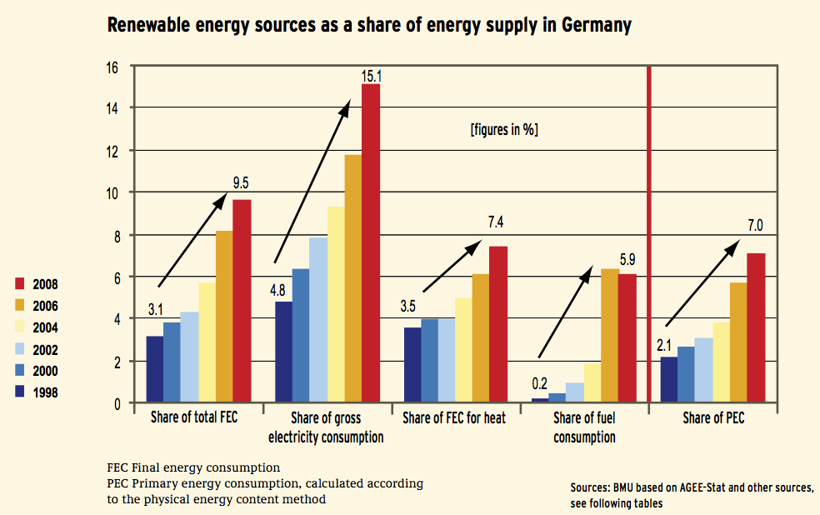

Figure 5: Renewable energy sources as a share of energy supply in Germany. (BMU, 2009)

Status and development of the German wind energy industry
In 2008 about 20,300 wind turbines were installed with a total capacity of 23,900 MW in Germany (see Figure 5). They generated 40.4 TWh electricity (7.5 % of net electricity consumption of Germany). In 2007, German wind energy industrie (manufacturers and suppliers the like) had a share of around 28% of the total worldwide turnover of 22.1 billion Euros.
As onshore wind power potentials are getting scarce in Germany the replacement of old and small installations by more modern and powerful ones (repowering) and the development of suitable offshore wind parks are further ways of market development. Moreover, manufacturers started to focus on international markets; their export quota was 83% in 2007 (after 16% in the year 2001).
In 2007 the total turnover of the wind energy sector amounted to 5,7 billion Euros. More than 249,000 jobs have been created in the renewable energy sector in recent years. About 84,300 people are currently employed in the wind energy sector alone. The wind power sector employs close to 100,000 people with an annual turnover of about 8 bn. Euro (BMU, 2009).
According to the German government’s strategy on offshore wind energy deployment the proportion of electricity generation from wind power is to be increased from its current level of around 7 % to at least 25%. The share of onshore wind energy will be 10% and thus considerably below the share of offshore power, which will be around 15%. The offshore wind power capacity of 20,000 and 25,000 MW is possible by the year 2030. The potential annual electricity yield form offshore wind farms is estimated to 85 to 100 TWh (BMU, 2007).
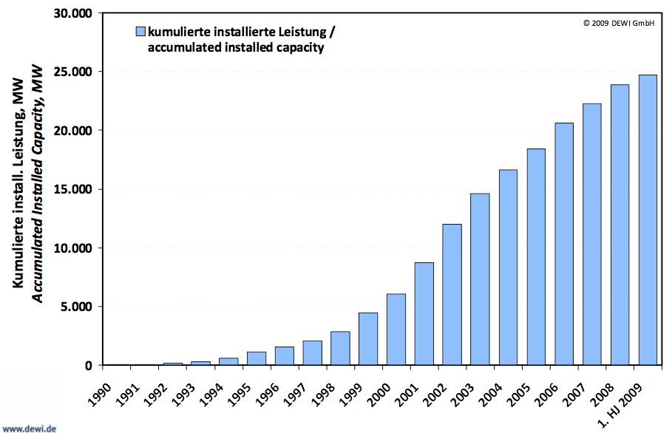
Figure 6: Installed wind energy capacity in Germany 1990 – 2008 (Dewi, 2009)

Incentives for German wind energy investors
The research, development and promotional measures of the German government and the favourable funding opportunities accelerated the wind technology deployment since the 1990s. There is a very strong correlation between the major incentive EEG and the development of the German wind energy market, see Figure 6.

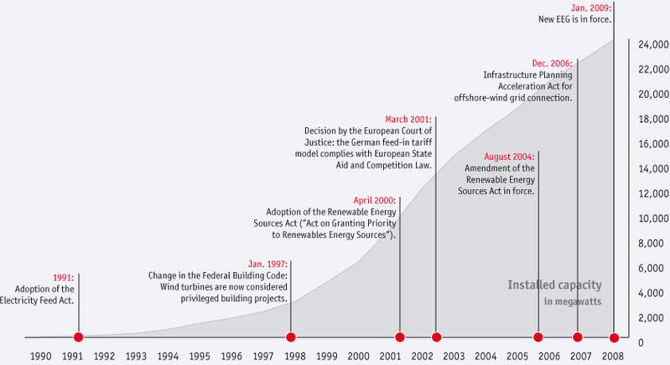
Figure 7: Growth of wind power generation capacity in Germany: and total capacites (BWE, 2009).

The producers of electricity from wind energy receive feed-in tariffs, which are defined in the German Renewable Sources Act (EEG). These feed-in tariffs offer planning security for manufacturers, service providers and wind energy investors. The initial tariff for new onshore wind turbines is 9.2 EUR ct/kWh since 1 January 2009. This value will be decreased every year by 1 % for newly commissioned wind turbines in order to take into account the technical development. The ‘initial tariff’ is fixed for at least 5 and up to 20 years for wind energy, depends on the wind turbine location. The initial tariff is reduced to a ‘basic tariff’ depending on how local wind conditions compare to the so called ‘reference yield’. Wind turbines at very good sites (with reference yield of 150 %) receive an initial tariff e.g. for five years, while for turbines on less favourable sites this period can be extended. The tariffs are paid for 20 years.
If onshore wind turbines replace old ones, the initial feed-in tariff is increased by 0.5 EUR ct/kWh. The new turbines have to come to the same or a neighbouring administrative district, the new capacity must achieve at least double of the old capacity, and the replaced turbines should be at least 10 years old. The tariff of offshore turbines will be 15 EUR ct/kWh by the end of 2015, with a yearly decrease of 5% (dena, 2009).
The incentive scheme for wind power is rather complex, Annex 3: German feed-in tariffs gives an impression of the different elements of the EEG for onshore wind power production.
The EEG is not the only instrument to foster renewable energies and electricity from renewable energies in Germany. However, it is the core of Germany’s renewables strategy. Next to the EEG one continuously important regulation for the success of wind energy development is the German Federal Building Code. Under this law wind energy plants are listed as so called ‘privileged projects’. Local authorities are in this respect asked to designate specific priority zones for wind energy utilisation. Additionally a bonus for improved grid compatibility was introduced for new wind turbines. This allows 0.5 cent/kWh on top of the initial remuneration.

Solar energy utilisation and industry development
By the end of 2008, a total of 500,000 solar power systems had been installed on German roofs, with a total output of 5,308 MWp. The annual revenue of the PV sector has grown to over 8.7 billion Euros (dena, 2009).
There is a clear correlation between the creation of the political framework and the boom of the German PV industry, as is displayed in Figure 7.
Since the introduction of the Renewable Energy Sources Act (EEG) in 2000, and particularly since its amendment in 2004, the photovoltaic industry has grown dramatically.
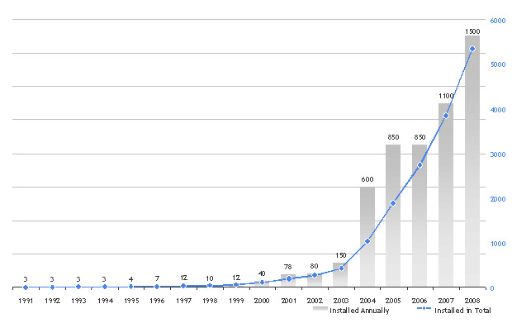
Figure 8: Growth of PV capacity in Germany: annually installed and total capacites. (BSW, 2009)

Incentives for the PV industry in Germany
The solar energy industry benefited from the EEG as well. Both private and institutional investors in photovoltaic systems receive the guaranteed remuneration for solar electricity fed into the grid. The tariff has been calculated so as to make investment in PV systems economically attractive. The EEG also provides planning security for investors both in PV systems and in PV companies who work on the assumption of continuous growth in the PV market. As for wind power, the feed-in law requires grid operators to pay producers of solar electricity a fixed remuneration for solar generated electricity that is fed into the utility grid, depending on the size of the system and the kind of the installation. These tariffs vary in order to account for the different costs of rooftop or ground-mounted systems and in accordance with the size of the system. The EEG guarantees PV operators a feed-in tariff fixed for 20 years and a purchase guarantee for the electricity produced, which makes investing in a solar electricity system an attractive investment for 20 years. The investment security is one reason for an enormous increase in the number of jobs in this sector. In order to bring about investments in a multitude of grid-connected systems, it is also necessary to clearly regulate grid access and transmission of electricity (dena, 2009). Annex 4: German feed-in tariffs gives an impression about the detailed incentive scheme.
The 2009 amendment of EEG decreased the feed-in tariffs for solar PV for all capacity sizes. For roof-mounted facilities, these are EUR cents 43.01/kWh up to 30kW, 40.91 from 30 to 100kW, 39.58 from 100kW to 1MW, and 33 over 1MW. For free-standing facilities the tariff decreased to EUR cents 31.94/kWh. The new law removes bonuses for building integrated facilities, however a new tariff of EUR cents 25.01/kWh has been introduced for systems up to 30kW when electricity produced is used within the building or facility.
The latest amendment of the German Renewable Energy Sources Act decreased the feed-in tariffs for solar power generated by installations on buildings and in open spaces. The sharp market price decline by 30% made the further lowering of the tariffs additionally to the original degression rate necessary. The feed-in tariff were reduced 11 % for solar farms on land converted from other uses (conversion areas) and 16 % for roof installations.
If the dynamic market development continues solar power may be generated at costs corresponding to those of regular consumer electricity tariffs as early as 2013. Therefore EEG amendment stipulates consumers' own consumption to a higher degree: private households that do not feed in solar electricity but consume it themselves gain up to 8 euro cent per kWh. For businesses the stipulation applies to installations with a capacity of up to 500 kW. This provision on own-consumption will trigger further important technological progress, e.g. in the field of storage technology. Consumption of grid electricity will be reduced, thus easing the burden on the grid. (BMU, 2010)
Open space installations can be promoted in a 100 m wide strip along the kerbside of motorways or rail tracks. Conversion areas allowing for tariffs pursuant to the EEG comprise land converted from residential building or transport use in addition to land converted from agricultural or military use. The category arable land cannot apply beyond 1 July 2010. (ibid.)
The PV development was (besides from the EEG) also supported by the 100,000-roofs-program that made low-interest loans available for small-scale investors (BMU, 2009).

Macro-economic effects of the EEG: Role on world markets and employment
German PV and wind turbine manufacturers are among the leading players on the international renewables markets. Research and development are other fields in which German companies and institutes gained a major position in international competition. Exports on global markets are increasing steadily, and today German companies are making a large share of their turnover internationally. This also means that the German industry „imported“ jobs, as non-German – international – market development creates jobs in Germany.
The renewable energy industry indeed created many jobs in recent years. This is true for all types of renewables (see Figure 8). The major job engines are wind power, biomass and the solar energy industry. Future development is seen positive, it is expected that this trend will e.g. in the solar industry lead to about 150,000 jobs by 2020 (BMU, 2009).
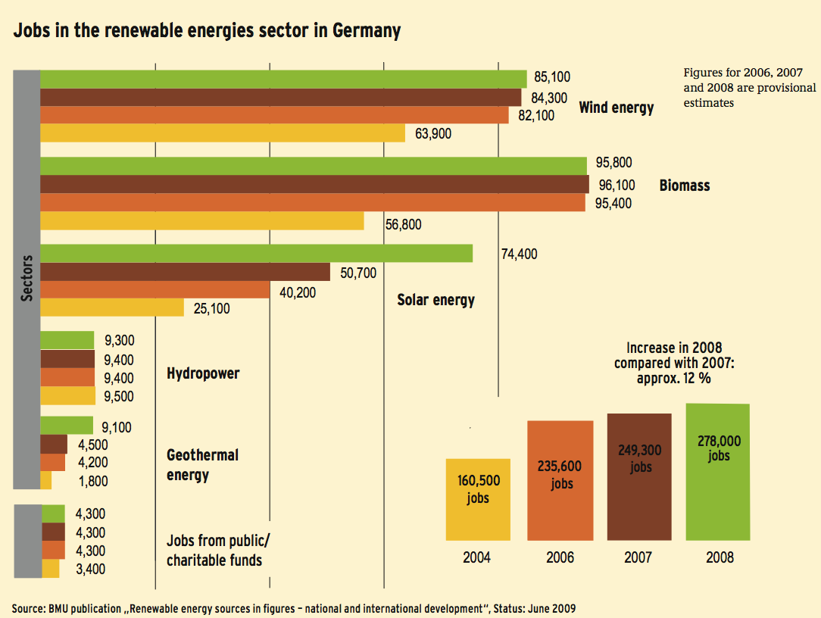
Figure 9: Job growth of the German renewable energy industry. (BMU, 2009)

Renewable expansion path: Development of contribution and economic costs
In Germany the Federal Ministry for the Environment has annual scenario studies conducted to determine available sustainable development paths in terms of climate protection and other aspects. These so-called lead studies are taking the most up-to-date developments into account to adjust the databases of the scenario calculations. For policy makers it is of high relevance to get insight into the total economic costs of renewable energy expansion on a broach national scale.
The additional costs of renewable energy expansion compared to the price level of conventional energy were in the Lead Study 2008 firstly determined on the basis of microeconomic costs, i.e. the unit costs of renewable energy production are set against the unit costs of energy production in fossil fuel powered plants. These additional costs are in general in the electricity sector of the same order of magnitude as the additional procurement costs under the German Renewable Energy Sources Act (EEG). Moreover, this also takes account of “old” hydropower from larger power plants, which is one of the most economical sources of electricity generation. The annual additional costs of the entire expansion of renewable energies amounted to 6.7 billion €2005/y r in 2007. Of these costs, around 60% were incurred for electricity supply (Figure 9). Different price paths were calculated in the Lead Study 2008. To show the general picture, it is sufficient to show the medium path for fossil energy price development. In this path the additional costs for renewables rise further to 8.5 billion €2005/yr in 2010 (of which 4.8 billion €2005/yr in the electricity sector, 1.7 billion €2005/yr in the heat sector and 2 billion €2005/yr in the fuels sector). After 2011 the additional costs drop continously. No additional costs arise after around the year 2020. By then renewable energies will meet almost 20% of total final energy demand and they already avoid 200 million t CO₂ per year. In the period from 2021 to 2030, renewables already „earn“ for the national economy about 6 billion €2005/yr. This sum which otherwise have to be afforded for the additional fossil energy requirements. In the period from 2031 to 2040 these savings grow further to 27 billion €2005 per year (Lead Study, 2008).
Tax revenues and other financial aspects were quantified recently in perspective to 2030. According to these data the solar energy industry will pay 40 bn Euro taxes in the coming 20 years. Avoided costs are also significant: they are estimated to amount to 16 bn Euro as avoided health and environmental costs. However, these costs are currently not included in macro-economic calculations. Avoided import costs for coal and natural gas are calculated to be 28 bn Euro cumulated until 2030 (BSW, 2009). This will be a major contribution to reduce import dependence and to keep expenses in a domestic investment cycle.

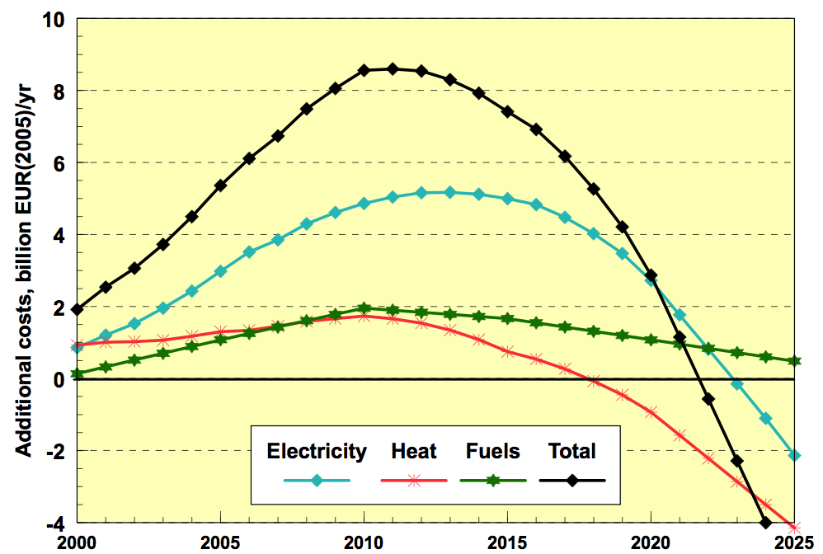
Figure 10: Additional costs of the German renewable energy expansion path in all sectors, Lead
Scenario 2008. (BMU, 2008)

Appendix 3: Spain: Case studies wind and solar power
Recently Spain has become one of the world leaders in wind and solar energy development. Besides the favourable natural – geographical conditions the national government and the autonomous regions see renewable energy as bringing environmental and energy security benefits as well as enhancing local employment and economic development. One of the main focus areas of the Spanish industry policy is renewable energy technology, with some remarkable success. In particular, As the recent IEA study about Spain’s energy policy states, „Spanish wind and solar technology providers are increasingly important for the country’s economic development, job creation and international trade. These developments are commendable and will help Spain tackle the climate change, environmental degradation and energy security risks“. (IEA, 2009 p 100)
Spain set the target of generating 30% of its total electricity demand from renewable energy sources by the year 2010. Half of that amount is supposed to come from wind power. In the year 2006, about 20% of the total electricity demand was produced by converting renewable energy sources; in January 2009 the total electricity demand produced with renewable energy sources reached 35%.

Development of the Spanish feed-in system
The liberalisation of the electricity sector was the first step toward renewable energy support in Spain. The Law (54/1997) of the electric sector liberalised the electricity sector and guaranteed electricity supply at lowest possible cost. It elaborated the plan for the promotion of renewable energy and the plan for achieving the goal of 12% of primary energy consumption from renewable sources by 2010. The law also established a special regime for producers, which are not allowed to surpass a maximum of 50 MW power. This law is implemented through royal decrees, most notably Decree 2818/1998, which specified the feed-in tariffs from which the generating plants under the "special regime" may benefit. The law established the guarantee of access to the grid for producers under the special regime. The law also established a premium, so that the price of electricity sold under the special regime is 80-90% of the mean price of electricity charged to final consumers.
This 24/2001 Law offered corporate tax deductions for investments in renewable energy sources. Renewable energy installations and equipments (with the exception of wind power equipment and installation) received 10% tax deduction.
The Spanish core incentive of renewable energy support scheme was provided by the feed-in law of 2004. The Royal Decree 436/2004 led to a booming Spanish renewable energy industry with renewables getting a larger and larger share in energy supply, see Figure 10.
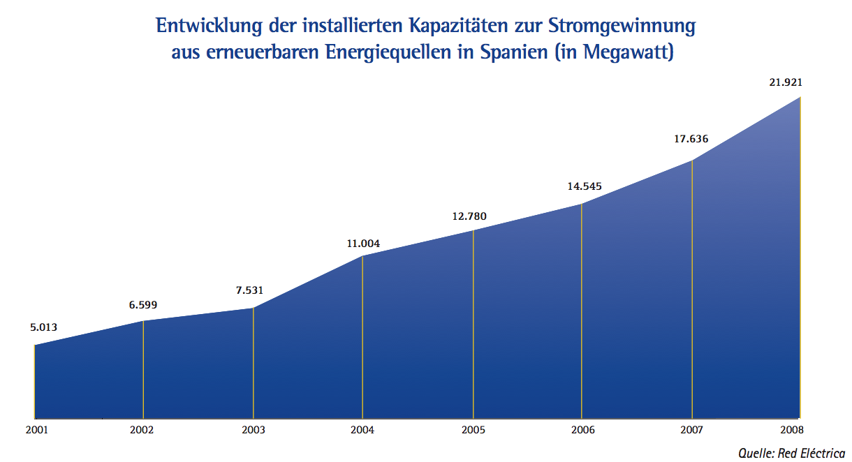
Figure 11: Growth of electricity generation capacity from renewable energies in Spain in Megawatt. (AHK, 2009)

The decree was set up to support electricity from renewable energy sources as an extension to the Electricity Act 54/1997. The German as well as the Spanish Feed-in laws support a wide range of renewable energy types. It provided incentives for new installed capacity of renewable energy sources in two different ways:
- Generators, who sold their electricity to a distributor, received a fixed tariff that was defined as a percentage of a regulated tariff. The percentage was established on a technology-by-technology basis. The reference tariff for 2004 was indirectly based on the production market price. The tariff was assessed on annual basis.
- Generators, who sold their electricity on the free market, received the negotiated market price of electricity and a premium, depending on the used technology.
With this decree the Spanish government removed economic barriers to the connection of renewable energy technologies to the electricity grid and equalised conditions for large-scale solar thermal and photovoltaic plants as well. The feed-in tariff was developed further with the Royal Decree 661/2007.
Royal Decree 661/2007 superseded the Royal Decree 436/2004 and introduced new tariffs and premiums for each kind of renewable energy source.
The new scheme involved all technologies, with technology-specific and capacity-specific limits, as well as a combined feed-in tariff and feed-in premium scheme. Furthermore, facilities with high system efficiency received a bonus. The decree covered every kind of renewable energy facilities, if their installed capacity does not exceed 100 MW (50 MW for hydro facilities). Up to 50MW, operators can choose between receiving a feed-in tariff price, or a feed-in premium paid on top of the market electricity price. Between 50 and 100 MW operators have the only option to receive a bonus amount fort he electricity produced. Solar PV systems are exempt from this arrangement.
Both the fixed feed-in tariffs and the premiums are calculated taking into account the average cost of each technology to ensure a minimum profitability. Each technology and type of installation has a specific target (maximum limit) for new installed capacity; the support scheme is guaranteed until this target is reached (IEA 2009).
The feed-in tariffs are paid during the entire time of a system's operation. However, after a certain time, these are reduced. This period is 25 years in the case of PV, while 20 years for wind power (IEA, Country Homepage).
The Royal Decree-Act 6/2009, of 30th April, established the Pre-assignment Registry for wind energy installations. Starting in May 2009, future renewable energy power projects must be pre-registered before they can eligible to receive feed-in tariffs. In order to be registered, a planned facility must meet all regulatory and administrative requirements, including building permits, provisions for transportation and distribution, grid access, and have adequate funding to cover at least 50% of investment costs.
It also allows to schedule the increase of power capacity for those technologies whose installed capacity exceeded the objectives set out by the Spanish Renewable Energy Plan 2005-2010. The decree aims to control the installed renewable energy capacity, as well as to provide technical feasibility of renewable energy integration into the electrical grid (IEA Country Homepage).

Wind power
The increase of wind power use is one of the major driver of renewable energy development in Spain currently. As Figure 11 shows, development of wind power installations was very dynamic in recent years. The electricity production from wind has grown from 5 TWh in 2000 to 32 TWh in 2008. Spain is the world’s third-largest wind power generator; its wind power production has more than quadrupled to 15 576 MW in 2008 and it is expected to continue to grow rapidly. The target, which was set by the Renewable Energy Plan 2005 – 2010 is to install a total of 20 GW of wind power by 2010 (IEA, 2009). The medium-term projections see continued significant investments in wind-based capacity as well. The Energy Infrastructure Investment Plan 2008-2016 contemplates 29 GW by 2016. Further increase is expected for 2020 in order to meet the EU target of 20% share of gross final consumption.
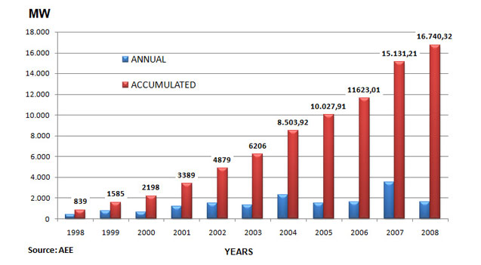
Figure 12. Growth of wind power capacity in Spain (AEE, 2009)
Wind power plant operators can choose one of the two support options for a period of at least one year:
- Sell the electricity to the grid operator and receive regulated feed-in tariff
- Sell the electricity on the wholesale market and receive market price plus a premium, which is varying according to the hourly wholesale (pool) price.
95% of the Spanish wind power plant operators decide on market sales, while only 5% on regulated feed-in tariff in 2008.
Annex 2 shows the level of public financial support and the total revenues of generators per kWh.
The following figure (Figure 12) illustrates the mechanism of the Spanish premium system for wind energy use.
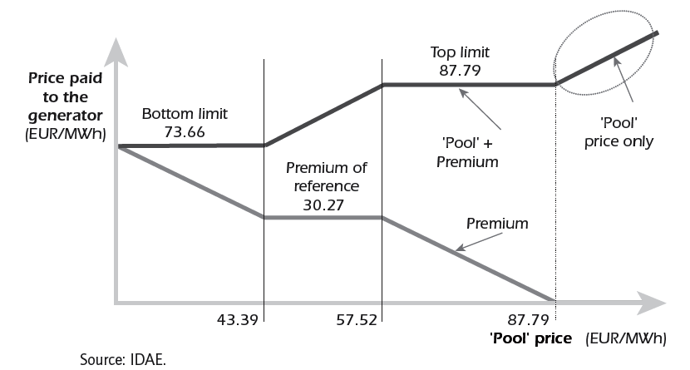
Figure 13: Spanish support system for wind power (2008) (IEA, 2009)
If the pool (wholesale) market price is lower than 43.39 EUR/MWh, the premium guarantees a revenue of 73.66 EUR/MWh. If the pool price varies between 43.39 and 57.52 EUR/MWh the premium is fixed to 30.27 EUR/MWh. When the pool price is higher than 57.52 EUR/MWh, the premium decreases that the total revenue amount to 87.79 EUR/MWh. Over the pool price of 87.79 EUR/MWh there is no premium for wind energy, the operator receives only the wholesale market price.
The level of feed-in tariffs, premiums and supplements is updated annually using the consumer price index as a reference minus 0.25 until the end of 2012 and minus 0.5 from 2013. The review of the support system is planned in 2010 in order to take into consideration the previous results and the cost-effectiveness of the system for each technology (IEA, 2009 p 97 - 98).
In order to encourage the development of offshore wind use, the Royal Decree 1028/2007 established administrative procedures for processing permit applications for electricity generation facilities in Spain's territorial waters. For offshore wind farms, this rule requires a minimum installed capacity of over 50 MW and establishes a system of competing bids.
However, currently onshore wind seems to be more attractive economically than offshore (IEA, 2009).

Solar energy: favourable conditions in Spain
Spain is fostering the use of solar energy with its feed-in law as well. Favourable conditions led to a multitude of intended PV solar projects, see Figure 13. Over 3,200 MW of PV power plant was installed in Spain by the end of 2008, and Spain become the leader of the world solar rankings. This spectacular year-on-year growth of 385% was fuelled by a generous feed-in tariff for PV solar energy and meant that Spain accounted for 45,2% of the growth in global PV solar market in 2008 (Bechberger, 2009).

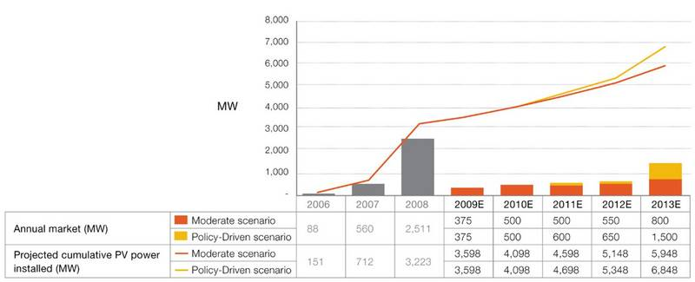

Figure 14: Cumulative PV power installed (in MW) in Spain from 2000 to 2008 and forecast 2009 – 2013 (EPIA, 2009)
The situation developed especially in 2008 very well for the renewable energy industry: „Annual installations of grid-tied solar PV reached an estimated 5.4 GW in 2008. Spain became the clear market leader, with 2.6 GW of new capacity installed, representing half of global installations and a ﬁve-fold increase over the 550 MW added in Spain in 2007.“ (REN21 2009, Global Status Report).
However, the Spanish government decided that the feed-in tariff was too generous and was leading to unsustainable levels of growth. As a result, the development is capped at 500 MW per year with the possibility to extend that cap to about 800 to 900 MW per year. Furthermore, the feed-in tariff for PV systems has been cut from EUR 0.45 per kWh to EUR 0.32-0.34, depending on the type of installation since the end of 2008. Annex 5 contains the new feed-in tariffs for PV solar energy. The reduction of the remuneration in 2009 slowed growth considerably.
The remuneration system (choice between two options) is similar to the system for wind energy.
Next to the feed-in tariff and premium system the Spanish Building Code is a further important regulation for the success of PV development.

Costs and benefits of the Spanish support scheme
The Spanish Renewable Energy Plan for 2005-2010 presented the energy targets set for each area of renewable energy technology, the measures necessary to meet those targets - including financing - and the lines of technological innovation and the benefits deriving from their application. The aim was to achieve at least 12% of total energy use from renewable sources by 2010, and 29.4% of electricity generated from renewable sources. The plan foresees public spending of 8.5 billion Euro of which around EUR 5.0 billion in premiums on electricity generation.
On the other hand the government expects that implementing the 2005-2010 Plan will lead to a total investment of EUR 23.6 billion from 2005 to 2010, of which EUR 0.7 billion would be public funding. The development of the renewable energy until 2010 should create 95 000 net jobs and avoid emitting 77 Mt CO2.
Table 8 shows the public spending in terms of CO2 emissions avoided or jobs created (IEA, 2009).

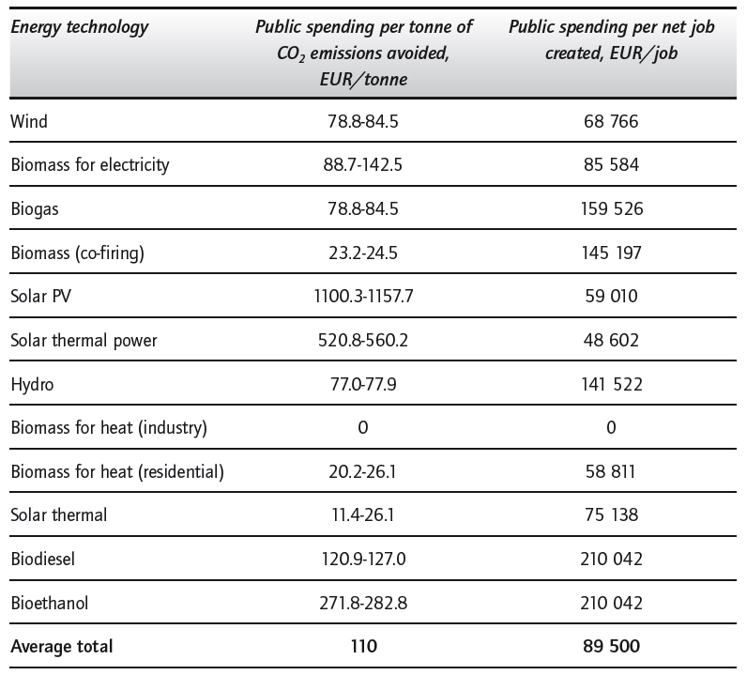
Table 8: Public Spending per Tonne of CO2 Emissions Avoided and per Job Created under the Renewable Energy Plan 2005-2010 (IEA, 2009)

Annex 4: German feed-in tariffs
Feed-in tariffs for onshore wind energy
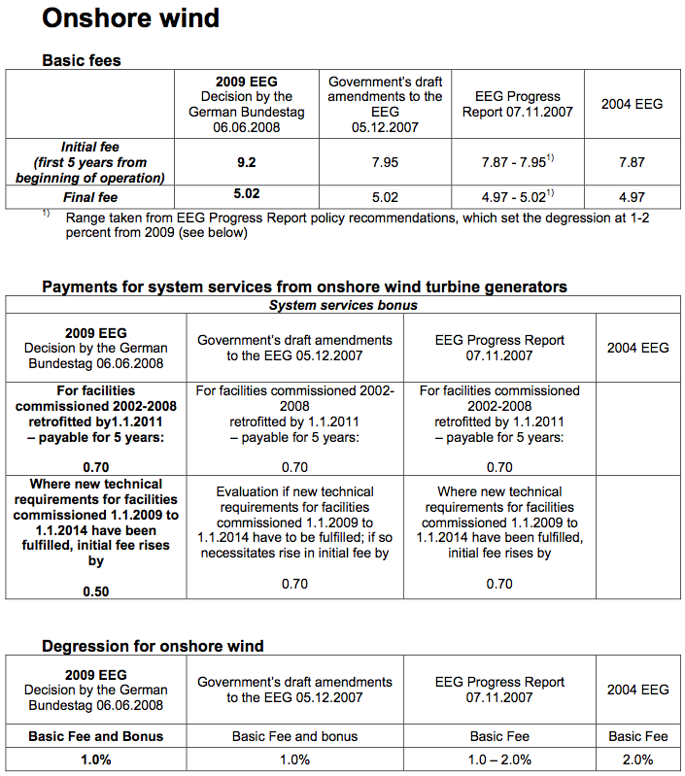
Feed-in tariffs for offshore wind energy
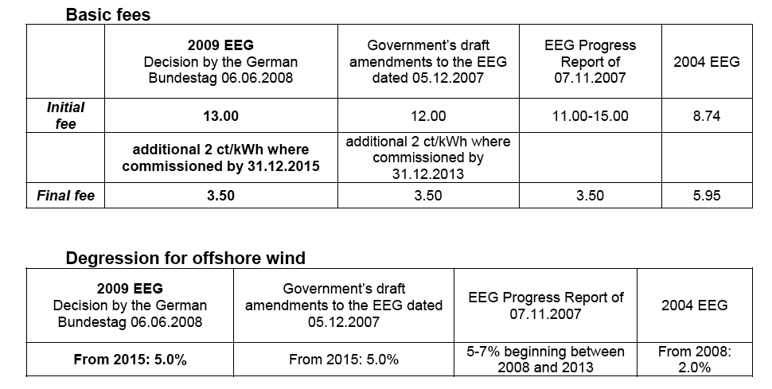

Feed-in tariffs for PV
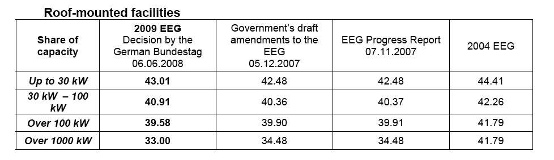
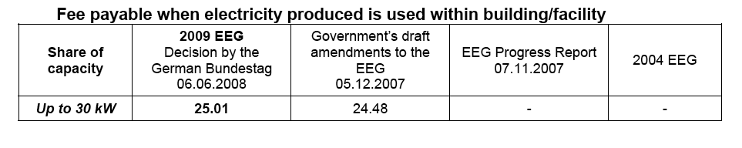
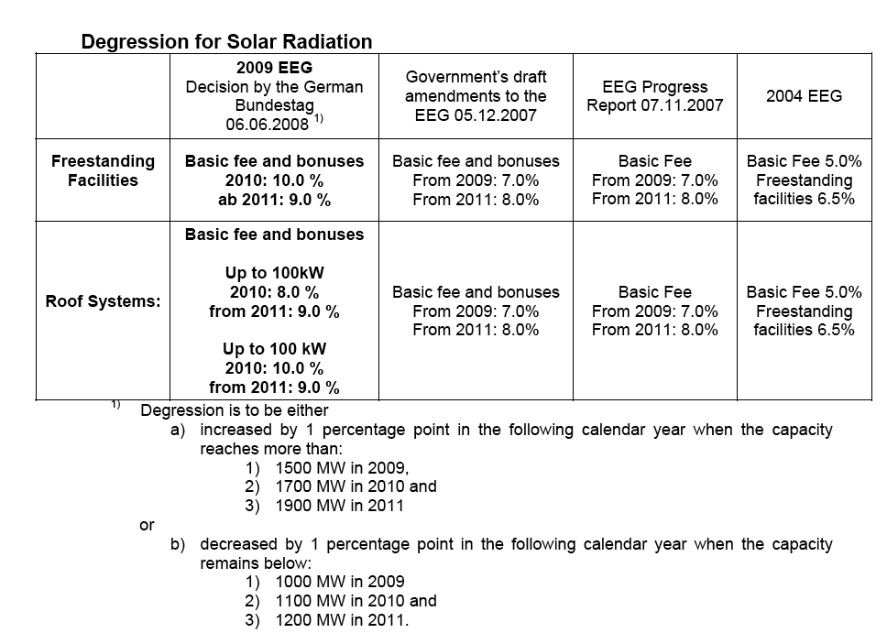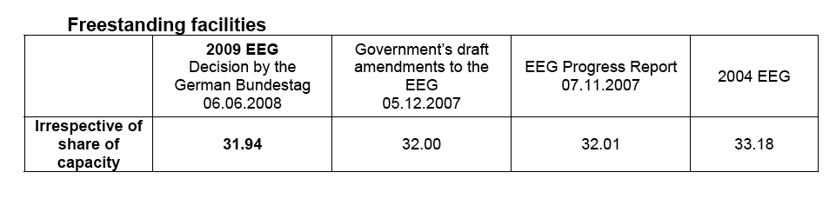
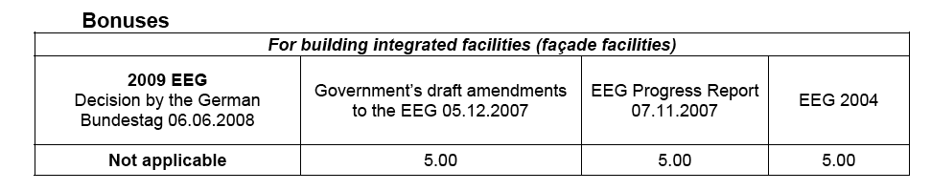

Annex 5: Spanish support schemes
Feed-in tariffs and premiums for electricity from wind and solar energy sources, 2008

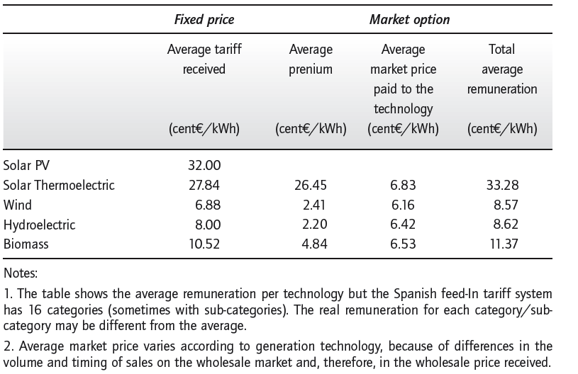
Source: IEA, 2009 p. 98

Feed-in tariffs for PV solar power plant since January 2009

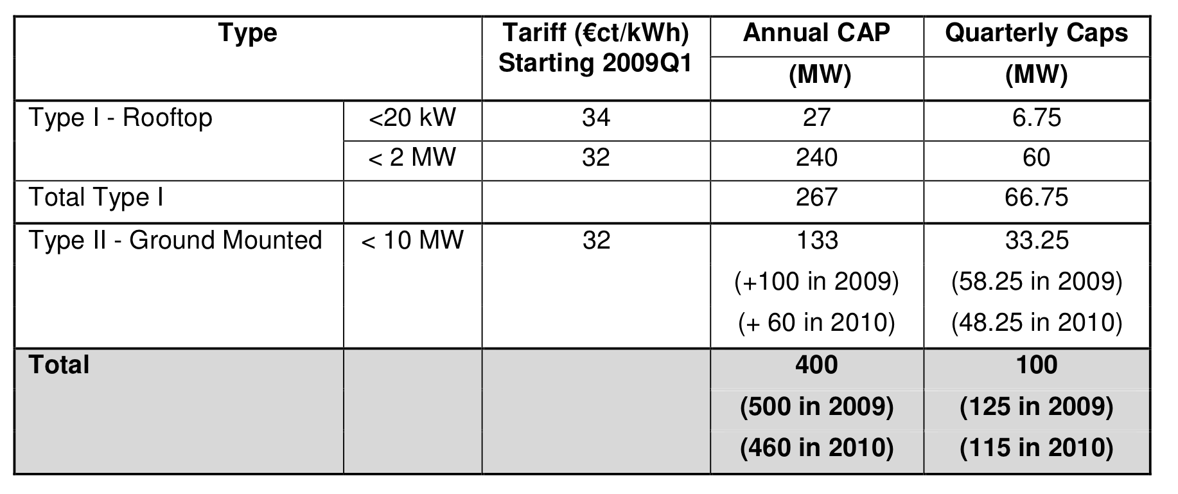
Source: EPIA National PV profiles in Spain (18/03/2009)

References
A Draft of National Document for Strategic Technology Development, Renewable Energies, Iran, November 2009
AEE (2009): Asociacion Empresarial Eolica: Installed Wind Energy capacity in Spain reaches 16,740 MW with new 1,609 MW in 2008; www.aeeolica.es/userfiles/file/notas-de-prensa/090202%20NP%20Installed%20wind%20energy%20capacity%20in%20Spain%20reaches%2016,740%20MW.pdf; last download: 18.01.2010
AHK (2009): Deutsche Handelskammer: Deutsch – spanische Wirtschaft, Tecnologías renovables de futuro, 2 0 0 9 Septiembre / Octure; http://www.ahk.es/fileadmin/user_upload/Revista/ECONOMIA_2009-3.pdf; last download: 18.01.2010
Appleyard, D., (2010) India’s Solar Spree. Renewable Energy World. 10 March, 2010. http://www.renewableenergyworld.com/rea//news/article/2010/03/solar-energy, last access 5 August 2010.
Atabi, F. (2004), Renewable Energy in Iran, Challenges and Opportunities for Sustainable Development, International Journal of Environmental Science and Technology, Vol. 1, No. 1, PP 69-80, Spring.
Bechberger, M. (2009): Erneuerbare Energien in Spanien, Erfolgsbedingungen und Restriktionen; Ecological Energy Policy, Band 10, ibidem- Verlag, Stuttgart
BMU (2010): Pressemitteilung vom 06.05.2010: Änderung der Solarvergütung beschlossen, Nr. 063/10, Berlin, 06.05.2010; http://www.erneuerbare-energien.de/inhalt/45985/4596/; last download: 06.09.2010
BMU (2009): Renewable energy sources in figures - national and international development; http://www.erneuerbare-energien.de/files/english/renewable_energy/downloads/application/pdf/broschuere_ee_zahlen_en_bf.pdf; last download: 18.01.2010
BMU (2007): Entwicklung der Offshore-Windenergienutzung in Deutschland / Offshore wind energy deployment in Germany; http://www.bmu.de/files/pdfs/allgemein/application/pdf/offshore_wind_deployment_de_en.pdf; last download: 17.12.2009
Butler, L., K. Neuhoff (2004): Comparison of Feed-In Tariff, Quota and Auction Mechanism to Support Wind Power Development. Cambridge Working Papers in Economics CWPE 0503
Bürer, M.J. and Wüstenhagen, R. (2009): Which renewable energy policy is a venture capitalist's best friend? Empirical evidence from a survey of international cleantech investors. In: Energy Policy 37 (2009), p. 4997-5006
BWE (2009): BWE Homepage: http://www.wind-energie.de/en/wind-energy-in-germany/, last download 18.01.2010
CEERS, HBS, WI (2005), Case Study: Solar Thermal Energy in Iran (2005). Executive Summary. CEERS; Wuppertal Institute for Climate Environment and Energy; Quadrat; University of Osnabrueck. Wuppertal/Tehran, p 15.
CERC, (2009) Press release. CERC notifies tariff regulations for green power. Central Electricity Regulatory Commission. 17 September 2009.
Cherni, J. A., and Joanna Kentish (2007), “Renewable Energy Policy and Electricity Market Reforms in China, Energy Policy, 35, 3616-3629
Danida, (2010), Provision of Technical Support/Services for an Economical, Technological and Environmental Impact Assessment of National Regulations and Incentives for Renewable Energy and Energy Efficiency. Desk Study Algeria. May 2010.
dena (2009): Renewables Made in Germany catalogue, online access: http://www.renewables-made-in-germany.com/; last download 18.01.2010
dewi (2009): Status der Windenergienutzung in Deutschland - Stand 30.06.2009; www.wind-energie.de/fileadmin/dokumente/statistiken/WE%20Deutschland/DEWI-Statistik_gesamt_2009.pdf; last download: 18.01.2010
DLR (2005): Concentrating Solar Power for the Mediterranean Region. Deutsches Zentrum für Luft- und Raumfahrt e.V. (DLR), Stuttgart
EPIA (2009): Historical PV market development in Spain; http://www.epia.org/policy/national-policies/spain/spanish-pv-market.html; last download: 18.01.2010
Fotouhi, Manuchehr (1994). Iran’s Geothermal Potential. International Geothermal Association, IGA News, Nr. 17, S. 5
Fotouhi, Manuchehr (1995). Geothermal Development in Sabalan, Iran. Proceedings World Geothermal Congress, Florenz, Mai 1995, S. 191 – 196
Fotouhi, Manuchehr, Younes Noorollahi (2000). Updated Geothermal Activities in Iran. Proceedings World Geothermal Congress 2000, Kyushu-Tohoku, 28.5. – 10.6.2000. S. 183- 185
Gipe, P., 2009. India’s 1.1 Billion Move to Feed-in Tariffs. Renewable Energy World. 1 October 2009. http://www.renewableenergyworld.com/rea/news/article/2009/10/
indias-1-1-billion-move-to-feed-in-tariffs?cmpid=WNL-Friday-October2-2009, last access 5 August 2010.
Gan L., Eskeland G. S., Kolshus H. H. (2007): Green electricity market development: Lessons from Europe and the US, in: Energy Policy 35 (2007) p. 144-155.
Grotz C., Fouquet D. (2005): Fixed prices work better, A comparison of renewable energy promotion gives thumbs up to feed-in schemes and opposes premature EU harmonisation; in: new energy 2/2005 p. 18 - 21
GTZ, TERNA (2009), Energy-Policy Framework Conditions for Electricity Market and Renewable Energies, 16 Country Analysis, Eschborn, November.
Hagenkort, Bert (2004). (Wind-)Verhältnisse im Iran. Erneuerbare Energien, Nr.7/2004
IEA (2009): Energy Policies of IEA Countries; Spain 2009 Review; International Energy Agency, OECD, Paris.
IEA (2007): Energy Policies of IEA Countries; Germany, 2007 Review; International Energy Agency, OECD, Paris.
IEA Country Homepage Germany: http://www.iea.org/textbase/pm/?mode=re&action=view&country=Germany last access: 18.01.2010
IEA Country Homepage Spain: http://www.iea.org/textbase/pm/?mode=re&action=view&country=Spain; last access: 18.01.2010
IEA-WI (2009): Energy Scenarios for Iran, German-Iranian cooperation project, Wuppertal Institute for Climate, Environment, and Energy, and Iran Energy Association.
IPCC, “Climate Change 2001: Mitigation”. A Report of Working Group III of the Intergovernmental Panel on Climate Change. Accra.
Lead Study (2008): Further development of the 'Strategy to increase the use of renewable energies' within the context of the current climate protection goals of Germany and Europe; http://www.umwelt-und-energie.de/inhalt/42726/3860/; last download: 18.01.2010
Kaufmann, D., A. Kraay, and M. Mastruzzi (2009) Governance matters VIII: Aggregate and Individual Governance Indicators 1996–2008, World Bank Working Paper No. 4978, Washington D.C. World Bank.
Kipke, Rüdiger (2004). Persönliche Kommunikation (Telefonat), 25.10.2004
Ministry of Energy, Department of Planning, renewable energy resources, various reports.
MNRE, 2010. Jawaharlal Nehru National Solar Mission: Towards Building Solar India. Mission Document. Ministry of New and Renewable Energy. 2010.
Moradzadeh, Faezeh (2009), Strengths, Weaknesses, Opportunities, and Threats for Renewable Energy in Iran, MS thesis, Azad University.
Nouraliee, Younes (2004). Persönliche Kommunikation mit Javad Nouraliee, Niroo Research Institute NRI, 4.10.2004, Teheran
Pew Center, (2008), Summary: India’s National Action Plan on Climate Change. Government of India. Pew Center on Global Climate Change. June 2008.
Purohit, I., Purohit, P., (2010), Techno-economic evaluation of concentrating solar power generation in India. Energy Policy 38 (2010): 3015-3029.
Ragwitz M. at al (2007): Assessment and optimalisation of renewable energy support schemes in the European electricity market, OPTRES Final Report, Karlsruhe
REN21 (2009), Global Status Report: Energy Transformation Continues Despite Economic Slowdown; http://www.ren21.net/globalstatusreport/g2009.asp; last download 18.01.2010
Renewable Energy Technology Development, the Oil Industry Research Academy, 2009Renewable Energy Organization of Iran (SANA), www.suna.org.ir
Río, P. del, Gual M. A. (2007): An integrated assessment of the feed-in tariff system in Spain, in: Energy policy 35 (2007) p. 992 – 1012. o.
Samimi J. (1994), Estimation of height-dependent solar irradiation and application to the solar climate of Iran. Solar Energy 52, 401 – 409
Rasuli Hamed (2010): http://news.tavanir.org.ir/press/press_detail.php?id=18013
Wuppertal Institute, Adelphi Consult, (2009), Energy Systems in OPEC Countries of the Middle East and North Africa: System Analytic Comparison of Nuclear Power, Renewable Energies and Energy Efficieny. August 2009.
Wuppertal Insitute, CREAD, (2010). Algeria – A Future Supplier of Electricity from Renewable Energies for Europe? Algeria’s Perspective and Current European Approaches. July 2010. In Press.

German legal acts:
Act on Renewable Electricity Feed-in (StrEG)
Renewable Energy Sources Act (Erneuerbare-Energien-Gesetz EEG)
German Federal Building Code

Spanish legal acts:
Law 54/1997
Decree 2818/1998,
Law 24/2001
Royal Decree 436/2004
Royal Decree 661/2007
Royal Decree-Act 6/2009
Spanish Building Code

The spread of general purpose technologies in the economy follows a logistic S shape form. At the infancy stage, the use of technology is slow as is costly and uncertain. The term “destructive creation” applies to the development of new technology as it creates new means of production and novel products by destroyingold technologies and products. In the second stage of technological development, when technology becomes cheaper and more widely available, the growth of new technology accelerates. Finally, at the end of the development process, the new technology dies out as it is being replaced by another newer technology.
http://www.suna.org.ir/ationoffice-windenergyoffice-windatlasmap-fa.html
A non governmental entity that has notified SANA its willingness to produce electricity from renewable energy sources

